**Practical No:- 1**

**Aim:-Implementation of Data Partitioning through Range Partition.**

SQL> create table sales_range80

2 (salesman_id Number(5),

3 salesman_name varchar2(30),

4 sales_amount number(10),

5 sales_date date)

6 PARTITION BY RANGE(sales_date)

7 (

8 PARTITION sales_jan2000 VALUES LESS THAN(TO_DATE('31/01/2000','DD/MM/YY')),

9 PARTITION sales_feb2000 VALUES LESS THAN(TO_DATE('28/02/2000','DD/MM/YY')),

10 PARTITION sales_mar2000 VALUES LESS THAN(TO_DATE('31/03/2000','DD/MM/YY')),

11 PARTITION sales_apr2000 VALUES LESS THAN(TO_DATE('30/04/2000','DD/MM/YY'))

12 );

Table created. 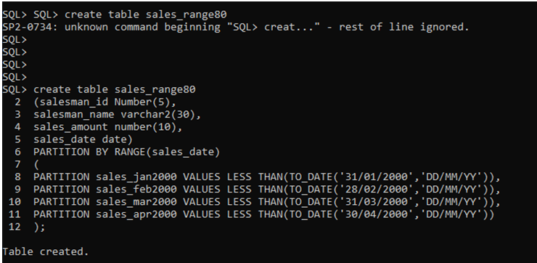 SQL> insert into sales_range80 values(1,'aarti',6000,to_date('15/01/2000','DD/MM/YY'));

1 row created.

SQL> insert into sales_range80 values(2,'prajakta',7000,to_date('18/01/2000','DD/MM/YY'));

1 row created.

SQL> insert into sales_range80 values(3,'diptii',8000,to_date('19/02/2000','DD/MM/YY'));

1 row created.

SQL> insert into sales_range80 values(4,'disha',9000,to_date('20/02/2000','DD/MM/YY'));

1 row created.

SQL> insert into sales_range80 values(5,'manoj',1000,to_date('21/03/2000','DD/MM/YY'));

1 row created.

SQL>

SQL> insert into sales_range80 values(6,'dishali',5000,to_date('22/03/2000','DD/MM/YY'));

1 row created.

SQL> insert into sales_range80 values(7,'manali',4000,to_date('23/04/2000','DD/MM/YY'));

1 row created.

SQL> insert into sales_range80 values(8,'sonali',3000,to_date('24/04/2000','DD/MM/YY'));

1 row created.

SQL> select*from sales_range80;

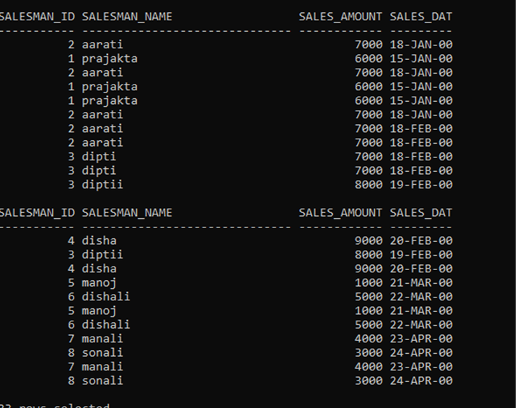SQL> select * from sales_range80 partition(sales_jan2000);

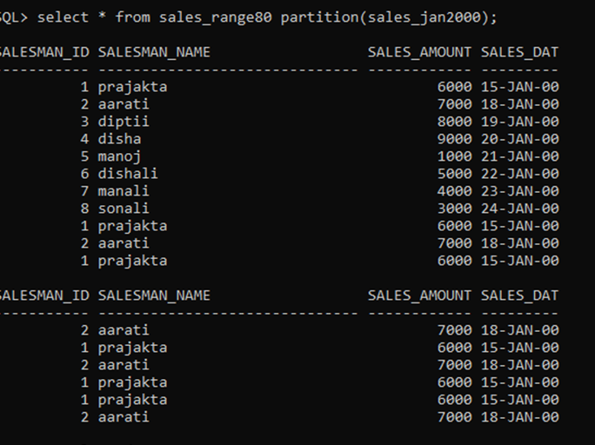 SQL> select * from sales_range80 partition(sales_feb2000);

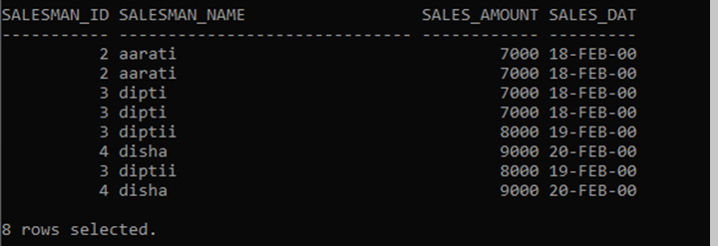 select * from sales_range80 partition(sales_mar2000);

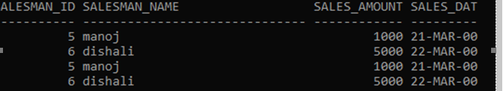

select * from sales_range80 partition(sales_apr2000)

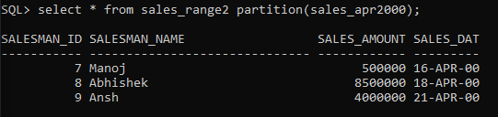

**Practical No:- 2**

**Aim:- Implementation data partitioning using list partitioning.**

SQL> create table sales_list5

2 (salesman_id number(5),

3 salesman_name varchar(30),

4 sales_state varchar(20),

5 sales_amount number(10),

6 sales_date date)

7 partition by list(sales_state)

8 (

9 partition sales_west

10 values('California','Hawaii'),

11 partition sales_east values('New York','Virginia','Florida'),

12 partition sales_central values('Texas','Illinois'),

13 partition sales_other values(default)

14 );

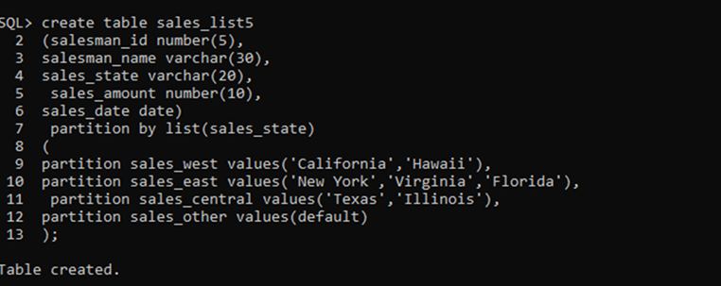 SQL> insert into sales_list5 values(10,'Dipti','California',2000,to_date('12/10/2023','dd/mm/yyyy'));

SQL> insert into sales_list5 values(10,'Prajakta','Texas',7000,to_date('13/10/2023','dd/mm/yyyy'));

SQL> insert into sales_list5 values(10,'Aarti','New York',8000,to_date('14/10/2023','dd/mm/yyyy')); 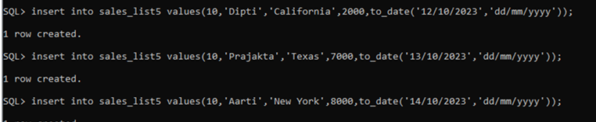 SQL> select * from sales_list5; 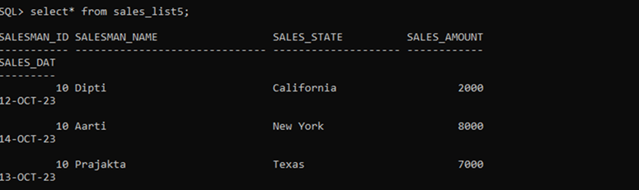 SQL> select * from sales_list5 partition(sales_west); 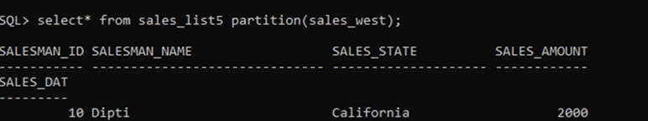 SQL> select * from sales_list5 partition(sales_east); 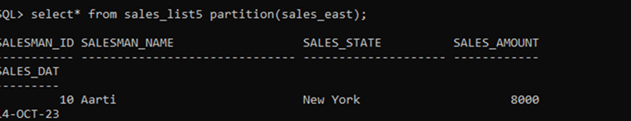

**Practical No:- 3**

**Aim:- Implementation of Analytical Queries. Ranks,dense rank,Lead,Lag.**

**Code:-**

SQL> create table student80(rollno number,name varchar(10),subject varchar(7),marks number);

SQL> insert into student80 values(80,'prajakta','ADTA',67);

SQL> insert into student80 values(97,'aarati','ADTA',68);

SQL> insert into student80 values(77,'dipti','ADTA',69);

SQL> insert into student80 values(13,'kajal','ADTA',66);

SQL> insert into student80 values(22,'manoj','SMS',27);

SQL> insert into student80 values(01,'dishali','SMS',87);

SQL> insert into student80 values(02,'disha','SMS',89);

SQL> insert into student80 values(03,'priyanka','java',90);

SQL> insert into student80 values(04,'prena','java',80); 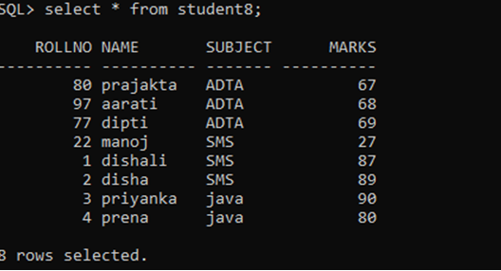

SQL> select rollno,name,subject,marks,min(marks) keep(dense_rank first order by marks) over

2 (partition by subject) as "lowest" from student80 order by subject,marks;

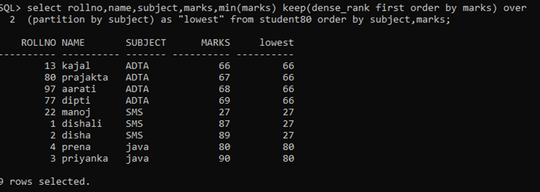 SQL> select rollno,name,subject,marks,rank() over(partition by subject order by marks)as "Rank" from student80; 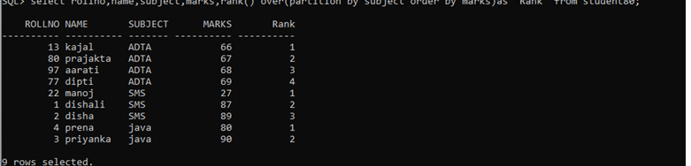SQL> select rollno,name,subject,marks,rank() over(partition by subject order by marks)as "Rank" from student80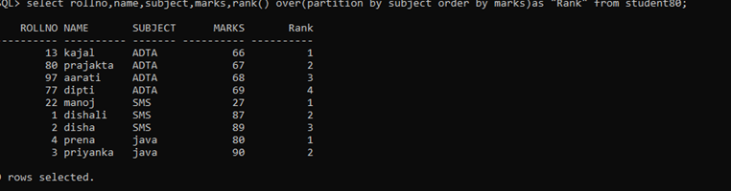 SQL> update student set marks=69 where rollno=97 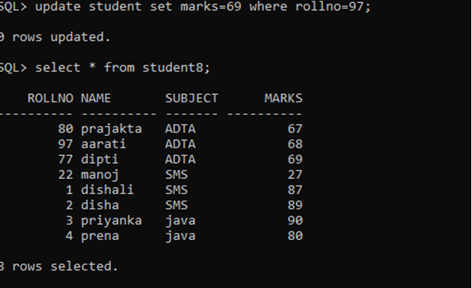

SQL> select rollno,name,subject,marks,rank() over(partition by subject order by marks)as "Rank" from student; 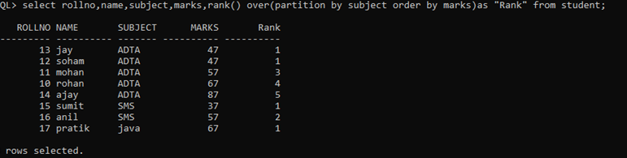 SQL> select rollno,name,subject,marks,dense_rank() over(partition by subject order by marks) as "rank" from student8;

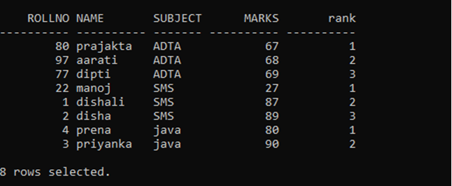

SQL> select subject,rollno,sum(marks) from student8 group by cube(subject,rollno)order by subject,rollno;

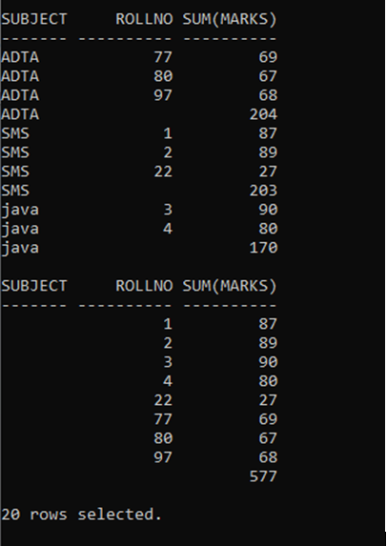

4)create a table employee with columns empid,emp_name,department,salary insert

6 records into the table and display lead and lag function.

SQL> create table employee80(emp_id number,name varchar(10),dept varchar(20),salary number);

SQL> insert into employee80 values(01,'prajakta','marketing',10000);

SQL> insert into employee80 values(02,'aarati','marketing',10200);

SQL> insert into employee80 values(03,'dipti','marketing',10500);

SQL> insert into employee80 values(04,'disha','IT',11000);

SQL> insert into employee80 values(06,'priyanka','sales',12000);

SQL> insert into employee80 values(07,'manoj','sales',12010);

SQL> select * from employee80;

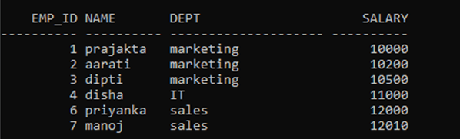

SQL> select emp_id,name,dept,salary,lag(salary,1,0) over(partition by dept order by salary)as "previous" from employee80;

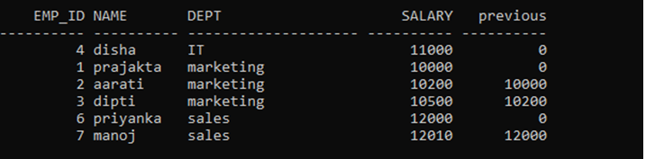 select emp_id,name,dept,salary,lead(salary,1,0) over(partition by dept order by salary)as

"next salary" from employee;

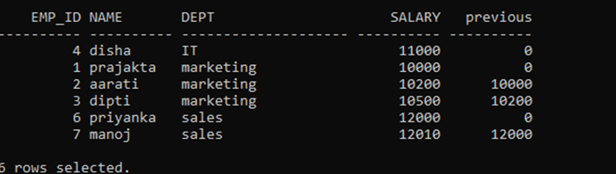

**Practical No:- 4**

**Aim:-Implementation of Analytical queries: Min, Max, Rollup, Cube.**

**1)Min**

SQL> select rollno,name,subject,marks,min(marks) keep(dense_rank first order by marks) over (partition by subject) as "lowest" from student3 order by subject,marks;

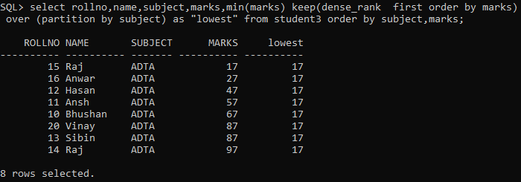

**2)Max**

SQL> select rollno,name,subject,marks,max(marks) keep(dense_rank last order by marks)over (partition by subject) as "highest" from student3 order by subject,marks;

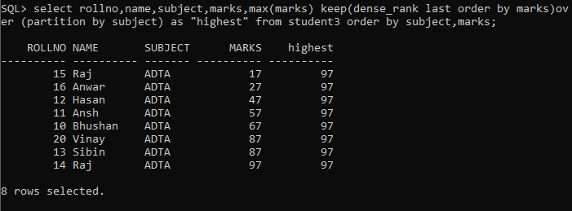

**3)Cube:-**

SQL> select subject,rollno,sum(marks) from student3 group by cube(subject,rollno)order by subject,rollno;

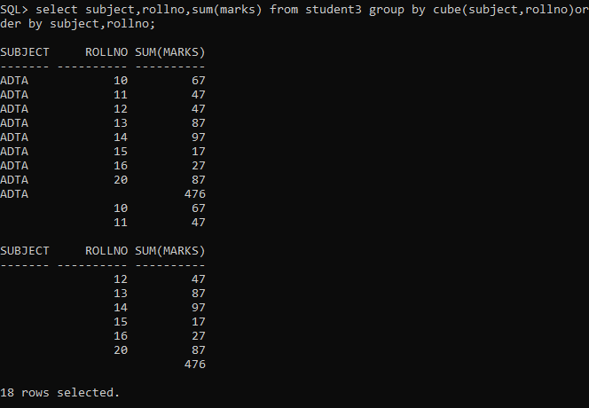

**4)Roll Up:-**

SQL> select subject,rollno,sum(marks) from student3 group by rollup(subject,rollno)order by subject,rollno;

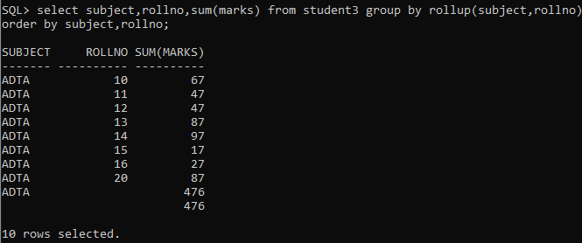

**Practical No:-5**

**Aim:- Implementation of ordbms (Abstract Data Types)**

SQL> create type type_name_5 as object(fname varchar(20),mname varchar(20),lname varchar(20))

2 /

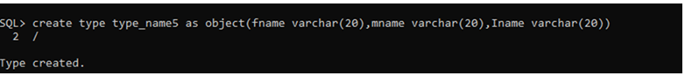SQL> create type type_address_5 as object(street varchar(20), city varchar(20),pincode number(10))

2 /

SQL> create table tb(c_id number(5) primary key,c_name type_name5,c_add type_address5,c_phno number(10))

SQL> insert into tb values(1,type_name5('Dipti','A','Kale'),type_address5('Kamothe','Navi Mumbai',410209),9326017360);

SQL>insert into tb values(2,type_name5('Prajakta','S','Kate'),type_address5('Ghansoli','Thane',410706),8878374837);

SQL> insert into tb values(3,type_name5('Prachi','v','Dubey'),type_address5('Bhandup','Thane',60706),6788374837);

SQL> insert into tb values(4,type_name5('Aarti','A','Pathare'),type_address5('Vikroli','Thane',78706),6788374837);

SQL> insert into tb values(5,type_name5('Disha','S','Mane'),type_address5('Bandra','Thane',78706),78976837);

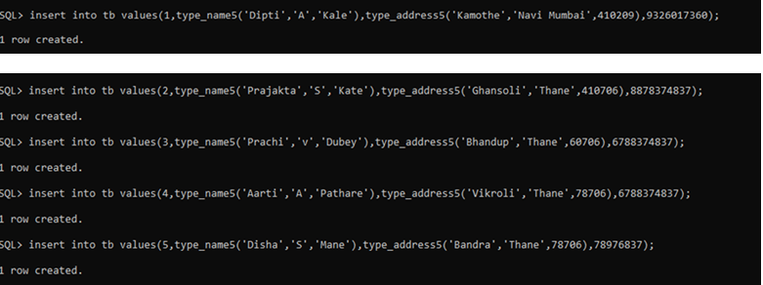

SQL>select*from tb; 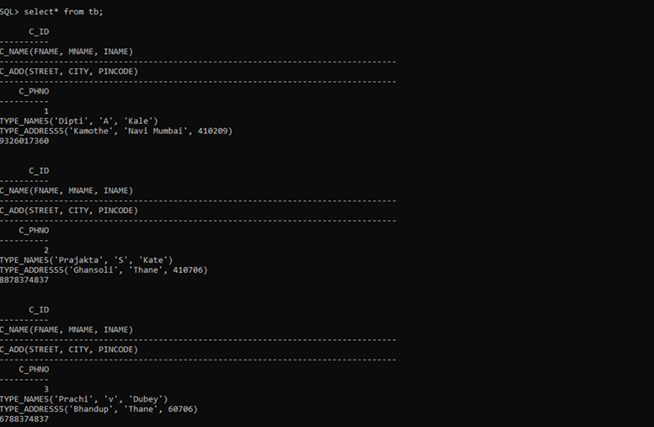

**Practical No:- 6**

**Aim:-Implementation of ETL transformation with Pentaho .**

**Table Input**

1)input folder🡪drag & drop🡪table input

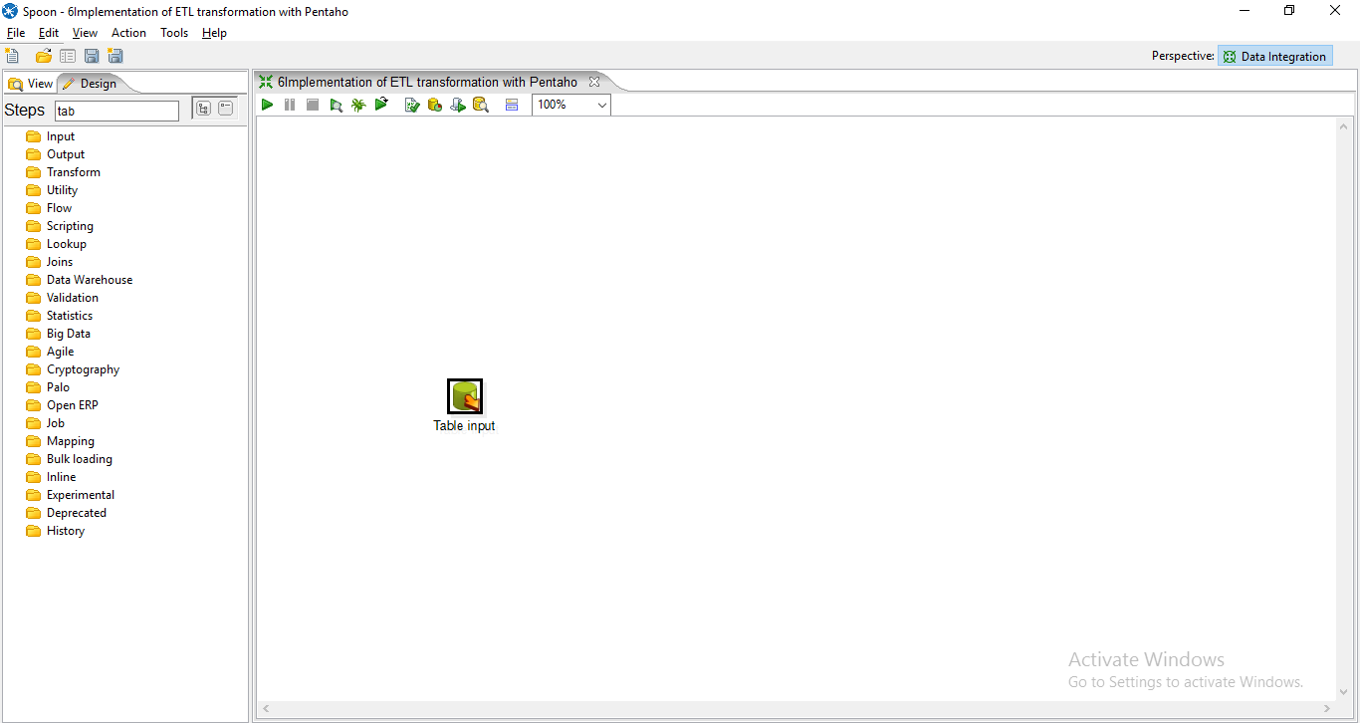

2)New🡪connection name

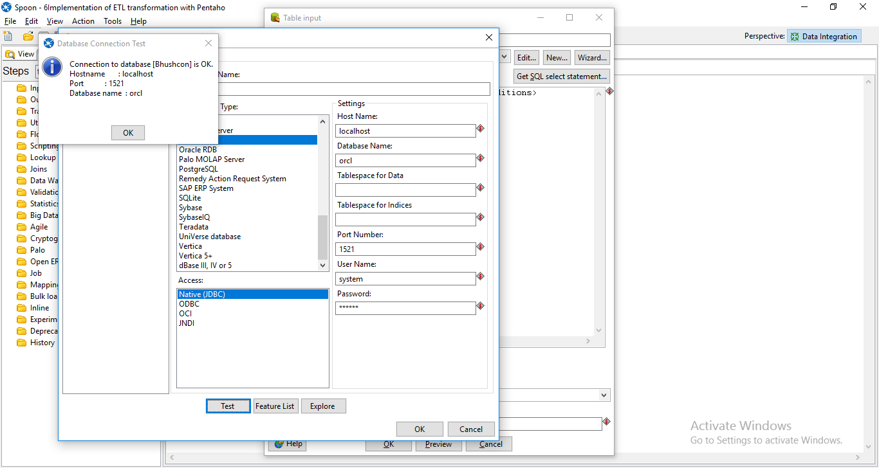

Click on🡪GET SQL SELECT STATEMENT🡪and select the table🡪then click on preview .

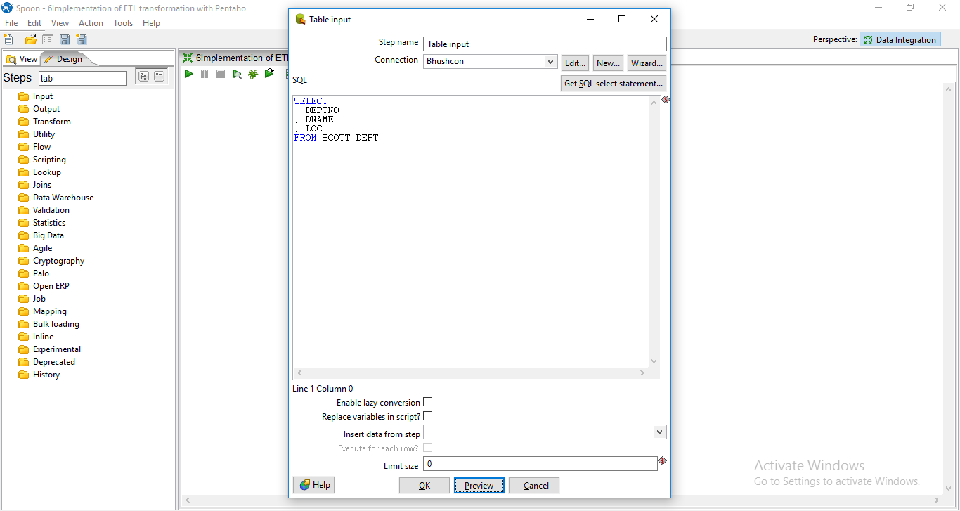

🡪Preview table

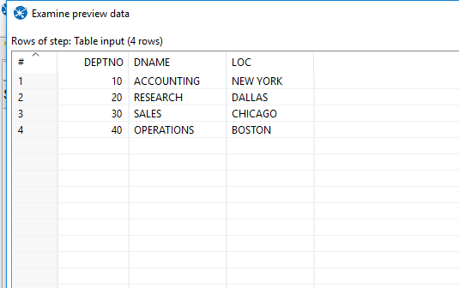

1. **Excel Input**
2. From input folder🡪drag & drop🡪 MICROSOFT EXCEL INPUT

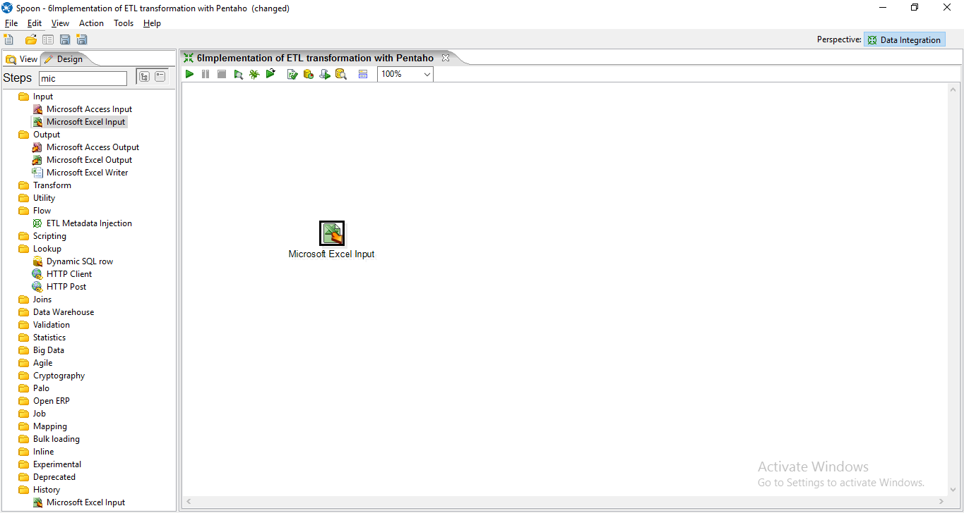

🡪Double click on it and add the Excel sheet.

1. **Calculator**

1 -> In transform folder 🡪drag & drop 🡪calculator🡪double click and details as follow🡪click Ok

1. 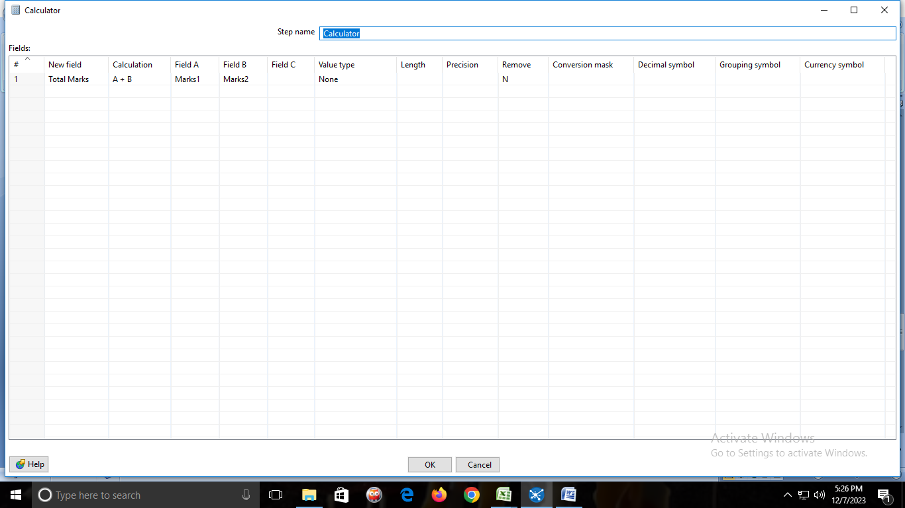

In Output folder🡪drag & drop🡪Microsoft Excel Output🡪double click🡪fields🡪get fields🡪OK

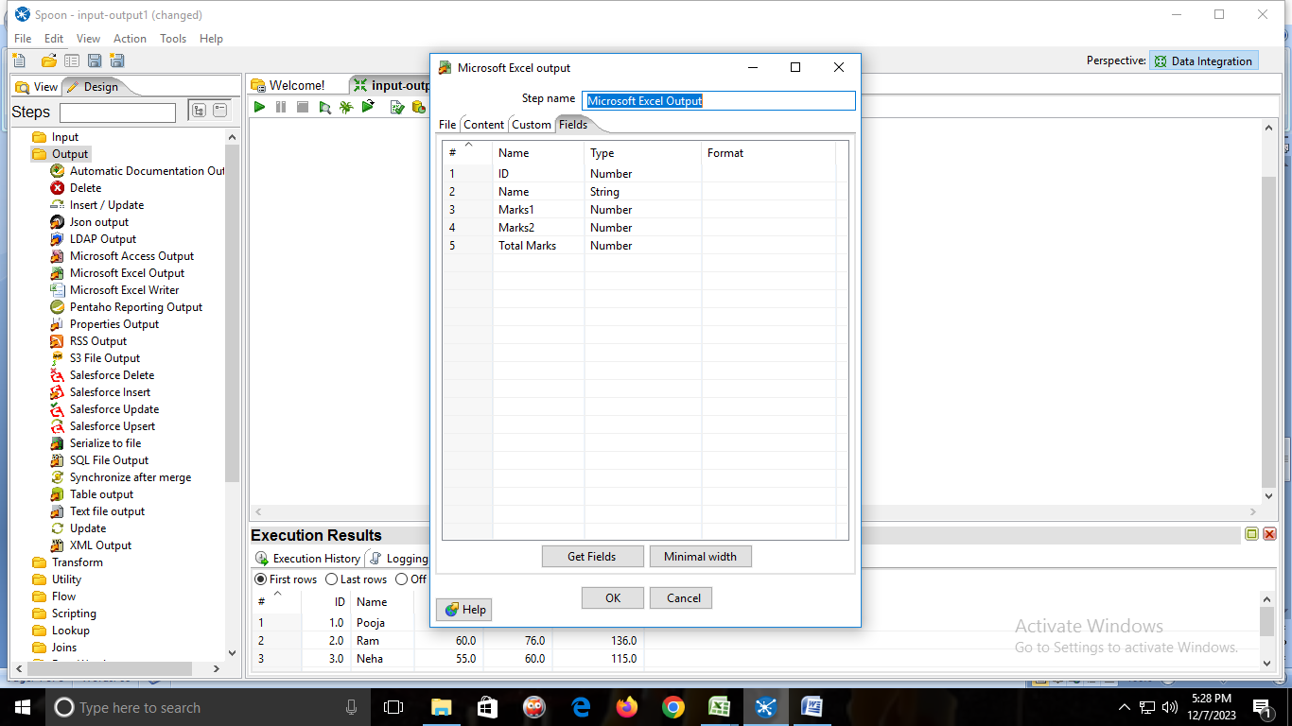

**OUTPUT:**

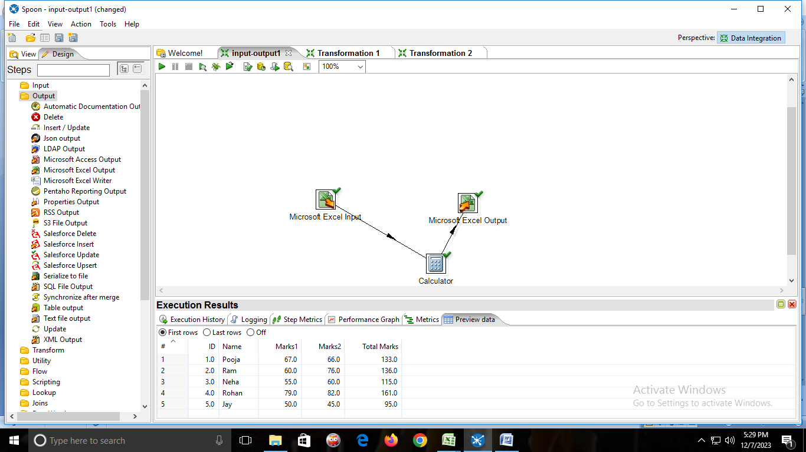

**d)Sequence**

Step1: Create an Excel file and save it.

Step2: Open Pentaho and create a new Transformation file.

Step3: In Design Tab go to Input -> Microsoft Excel Input. Drag and drop the Microsoft Excel Input from the Design Tab to the Transformation Page.

Step4: Double Click Microsoft Excel Input, browse your Excel file and add it to Selected Files in Microsoft Excel Input.

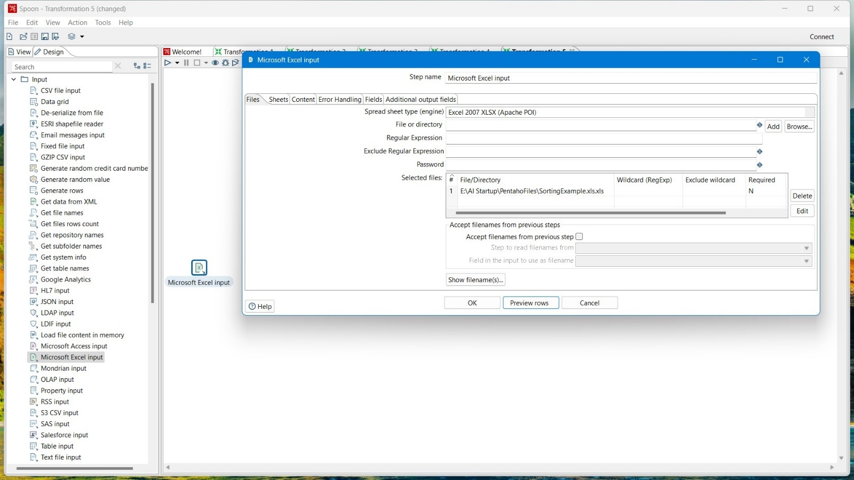

Step5: Navigate to Sheets menu in Microsoft Excel Input and Select the Sheet from excel file that contains your Data. Then Navigate to Fields Menu and click on “get fields from header row” and the click on “Preview rows”.

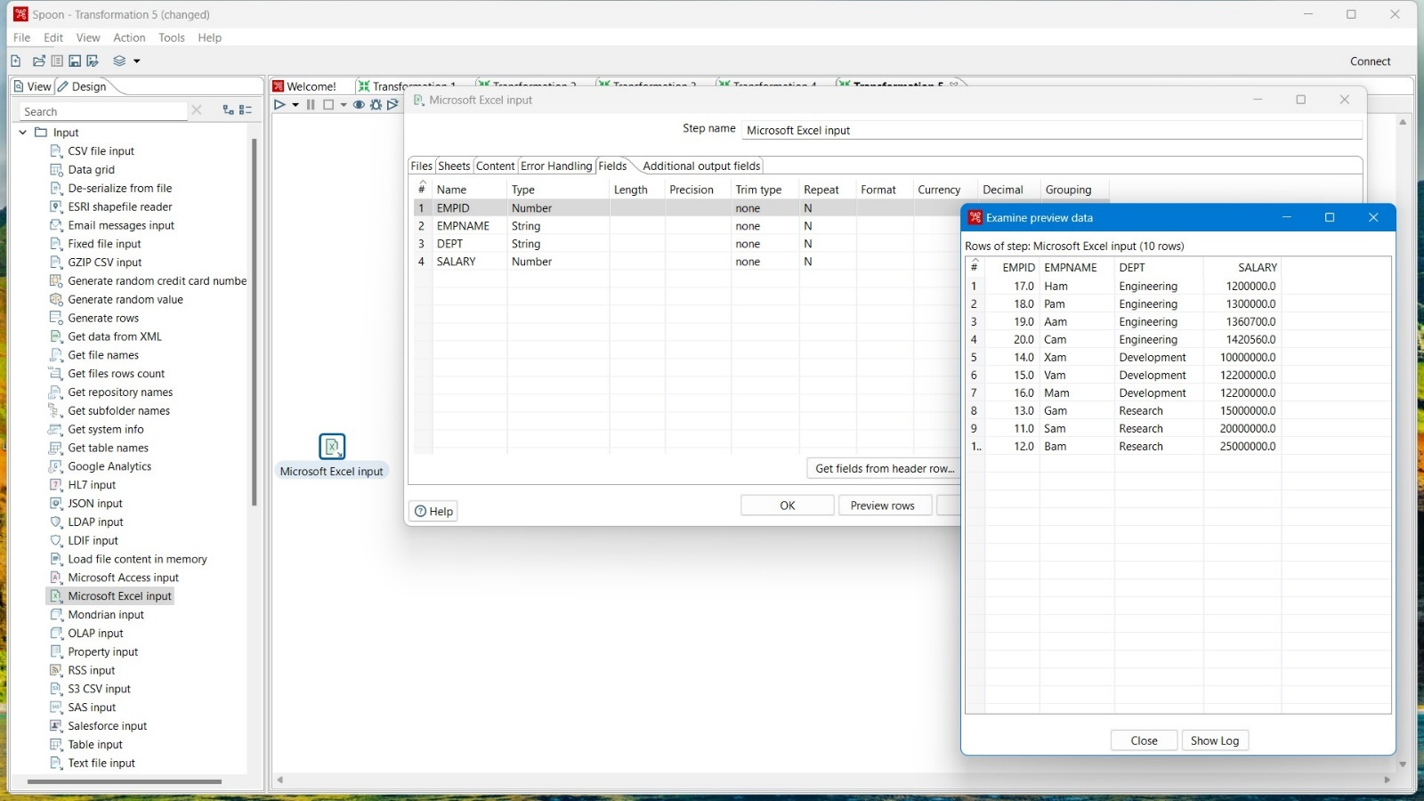

Step6: In Design Tab go to Transform -> Add Sequence. Drag and drop Add Sequence from the Design Tab to the Transformation Page.

Step7: Create a Hop-Connection Between Microsoft Excel Input and Add Sequence, and double click on it.

Step8: In the “Name of value” give the name of your new Field and set “Start Value” and “Increment Value”.

Step9: Then click ok.

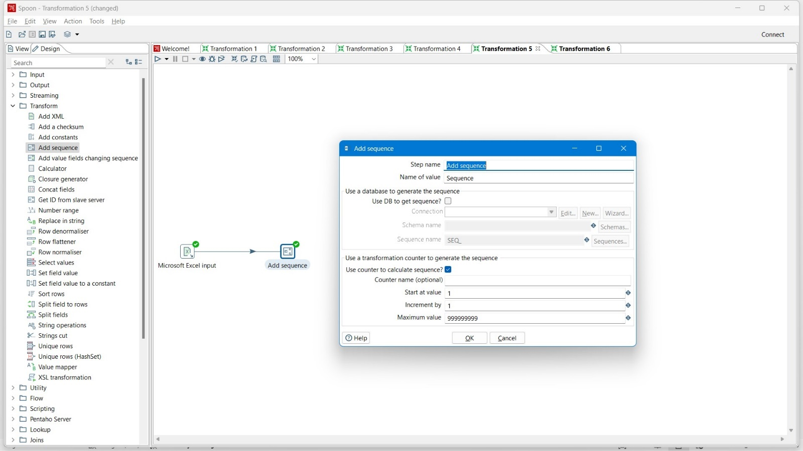

Step10: Run the Transformation.

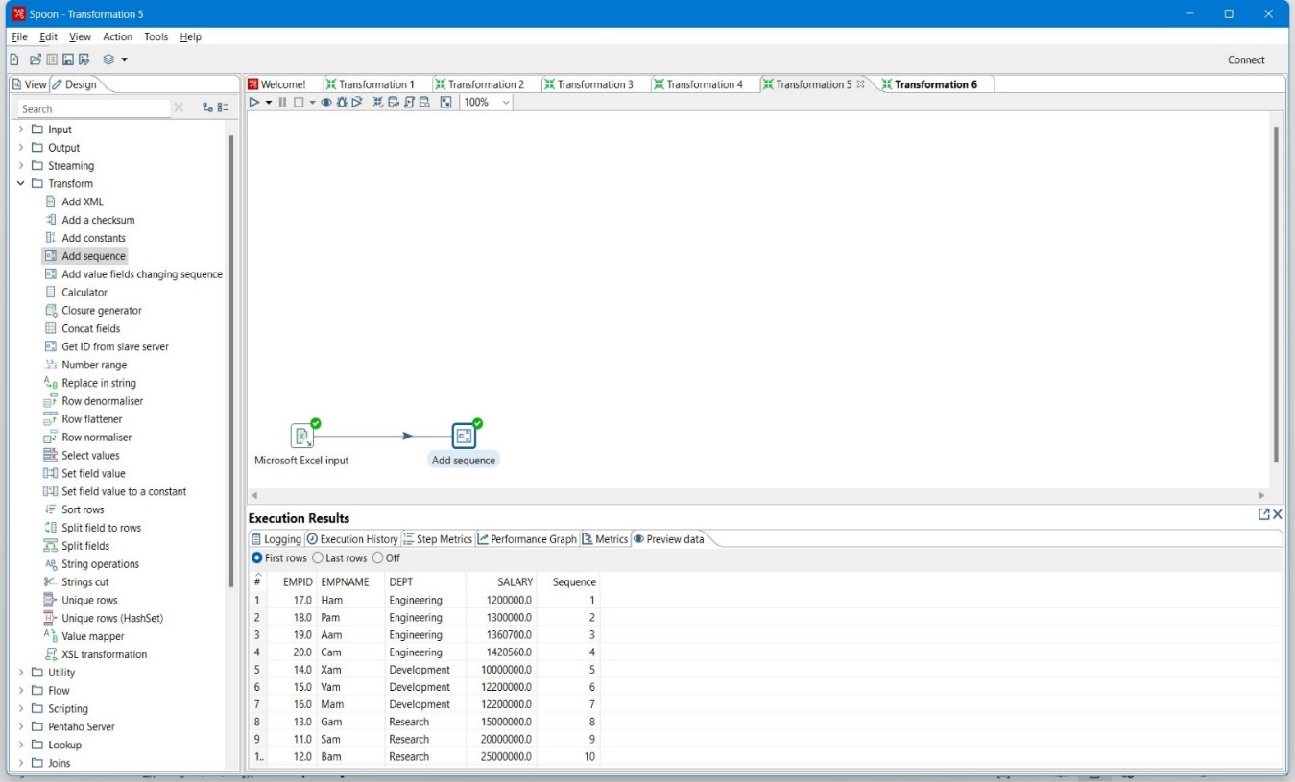

**E)Sorting, Null-If, Filter.**

1)input folder🡪drag & drop🡪table input

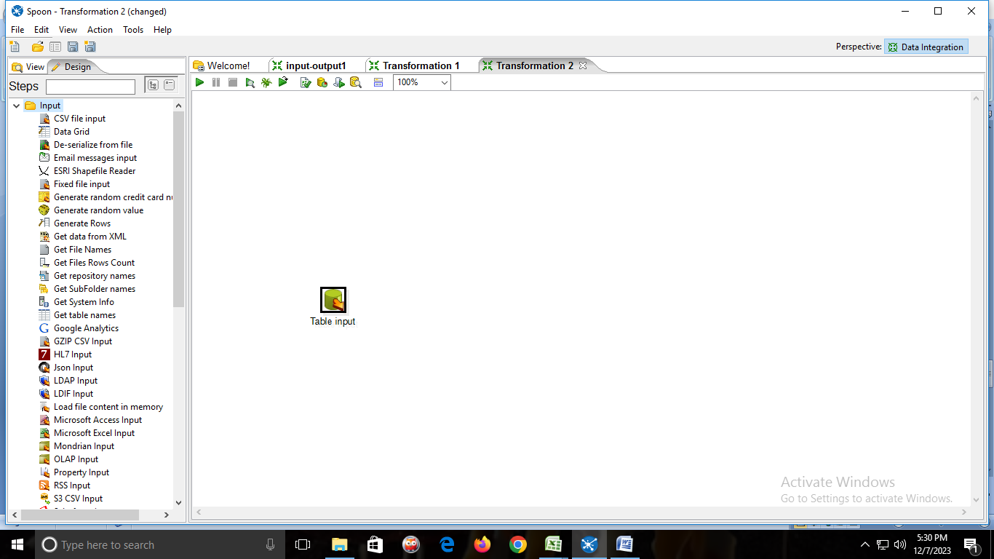

**2)New**🡪**connection name**

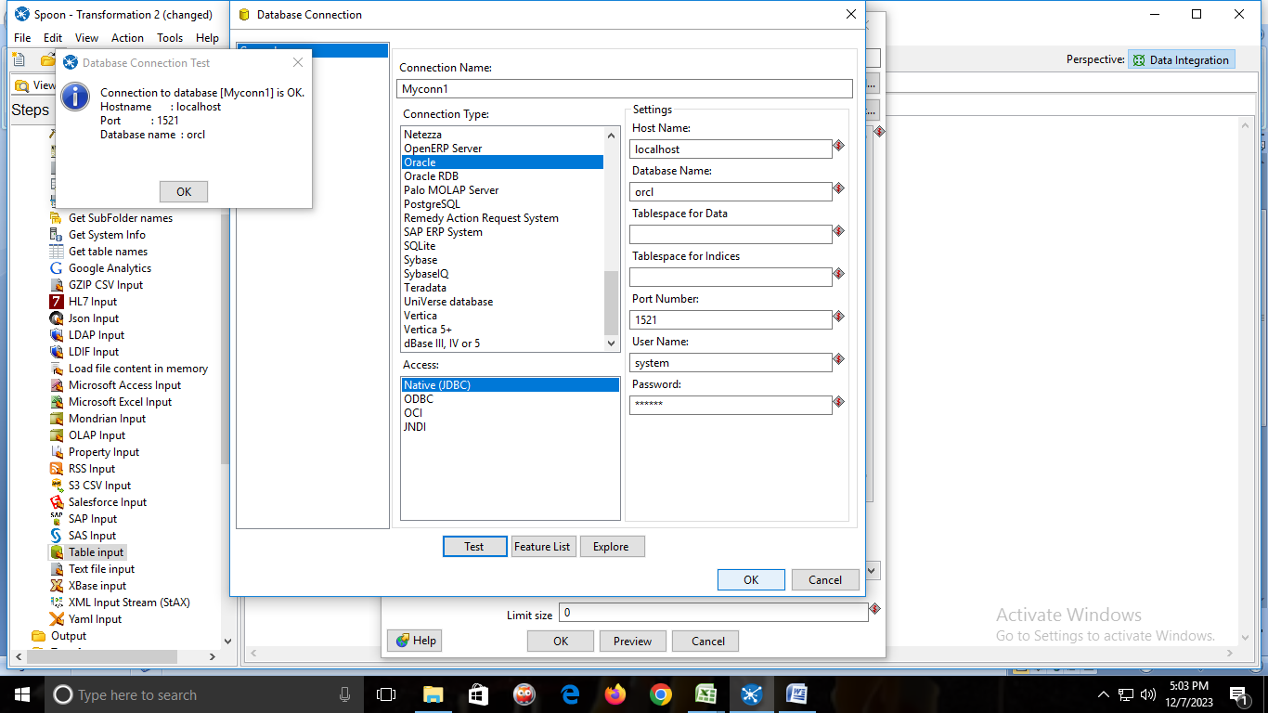

Click on🡪GET SQL SELECT STATEMENT🡪and select the table🡪then click on preview.

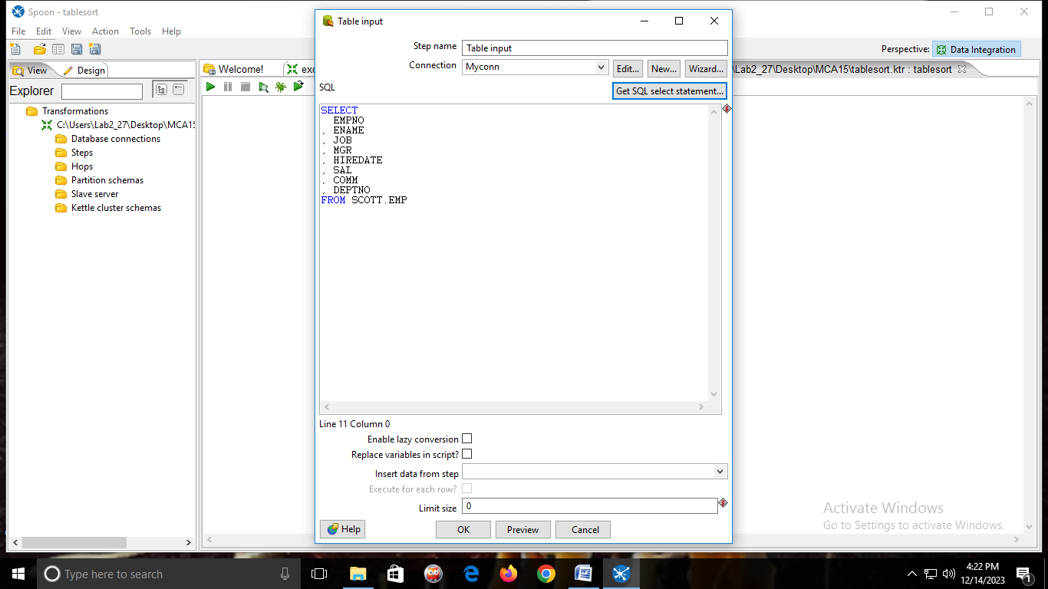

🡪Preview table

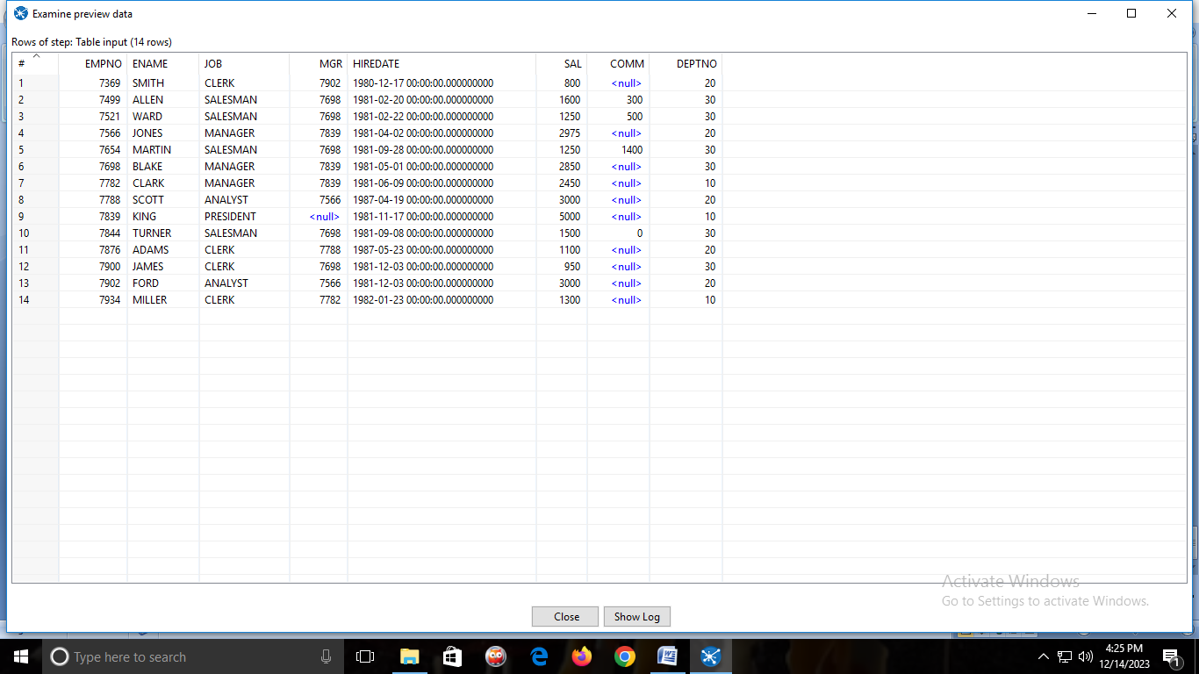

2)From transform folder🡪drag & drop SORT ROWS and connect table input to sort rows

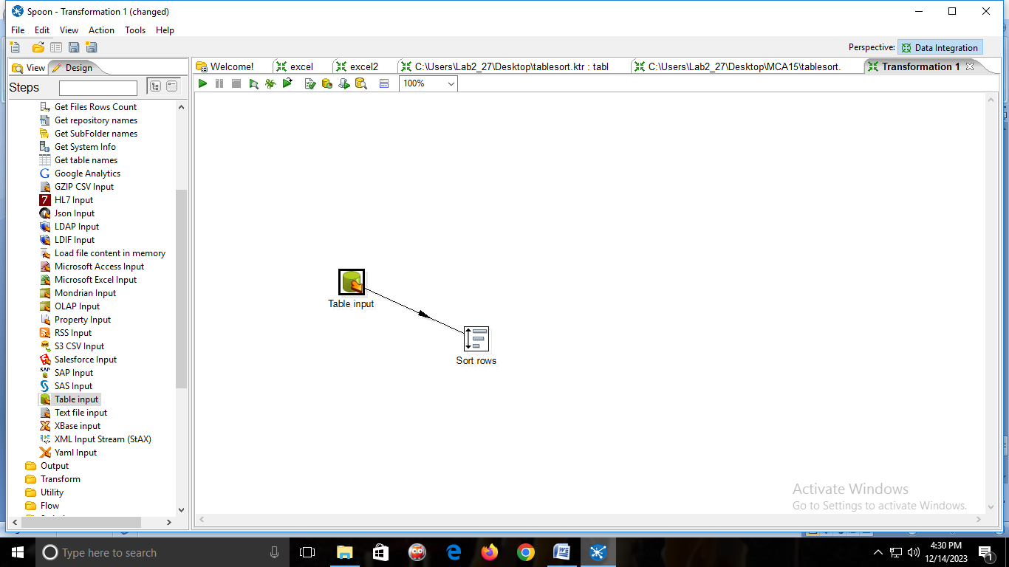

🡪Give the field name which we have to sort.

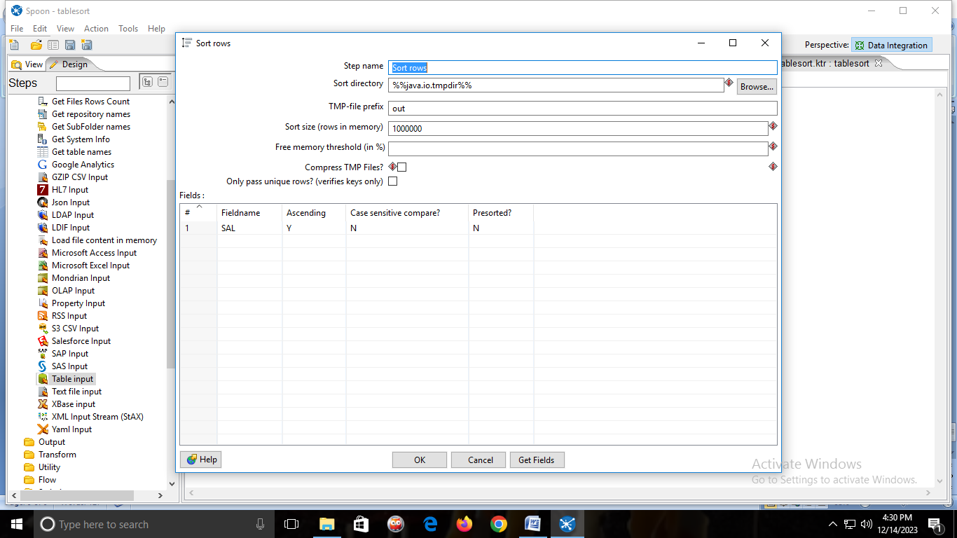

3)From Output folder 🡪drag & drop Microsoft excel output 🡪connect sort row with Microsoft excel output.

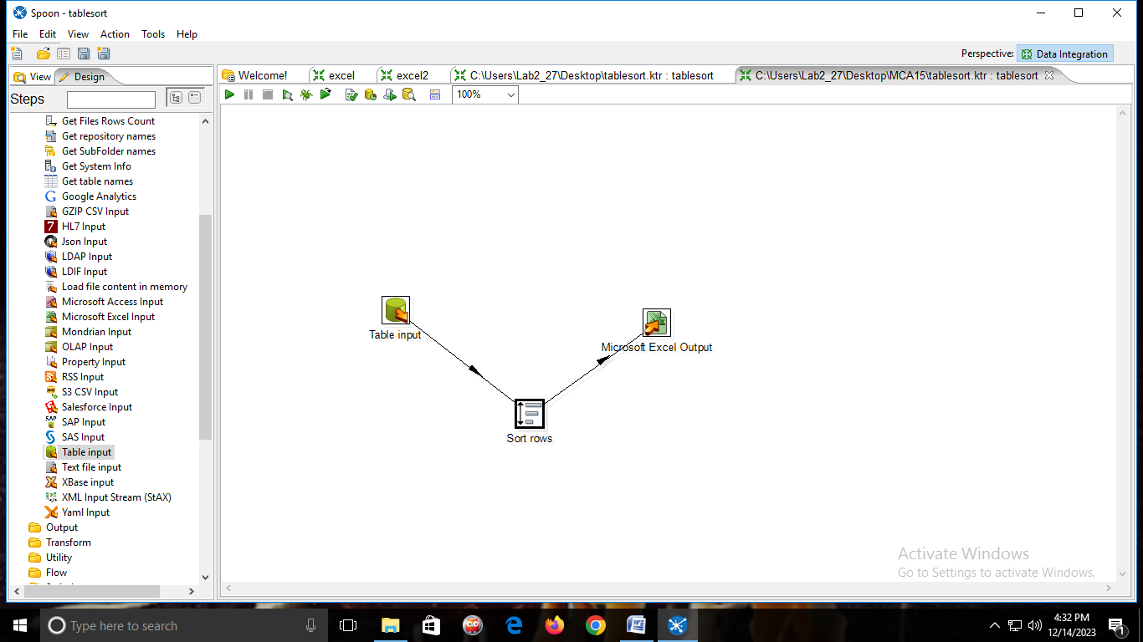

**OUTPUT:**

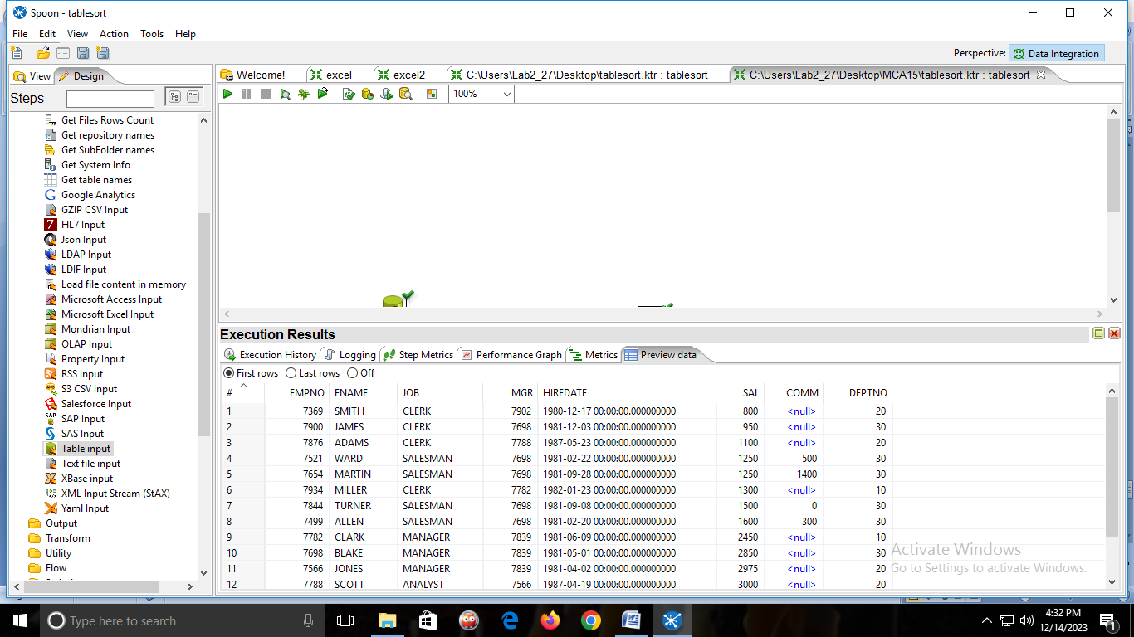

**Null-if.**

1)from input folder🡪drag & drop table input.



2)New🡪connection name



Click on🡪GET SQL SELECT STATEMENT🡪and select the table🡪then click on preview.



🡪Preview table



2)From Utility folder🡪drag & drop NULLIF and connect table input to nullif

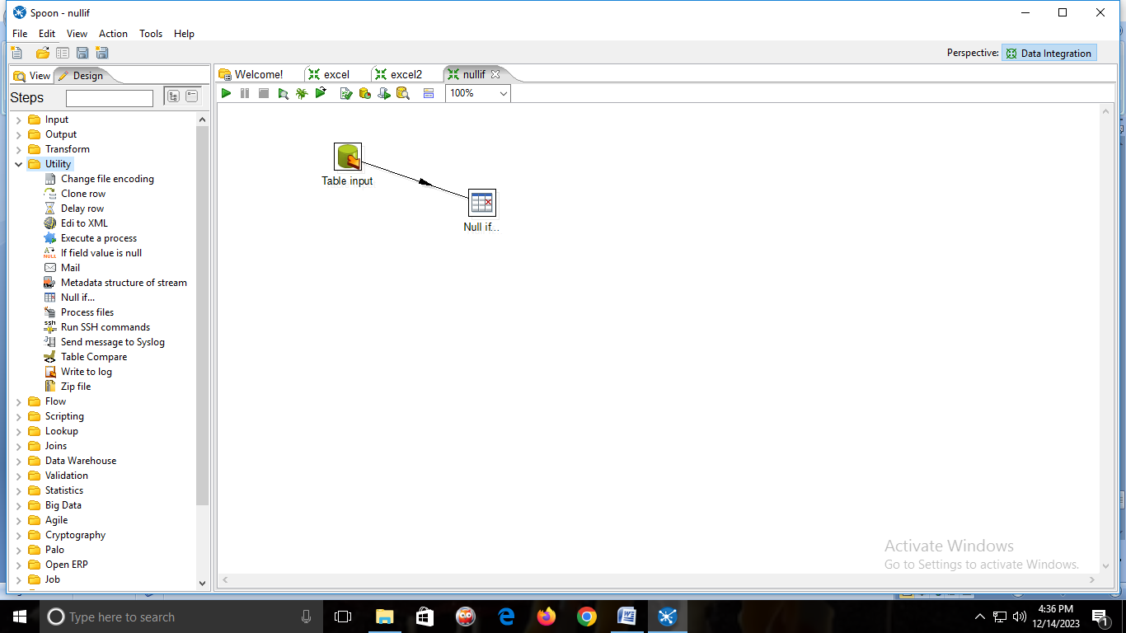

3)Double click on null if and give name and value to turn to NULL.

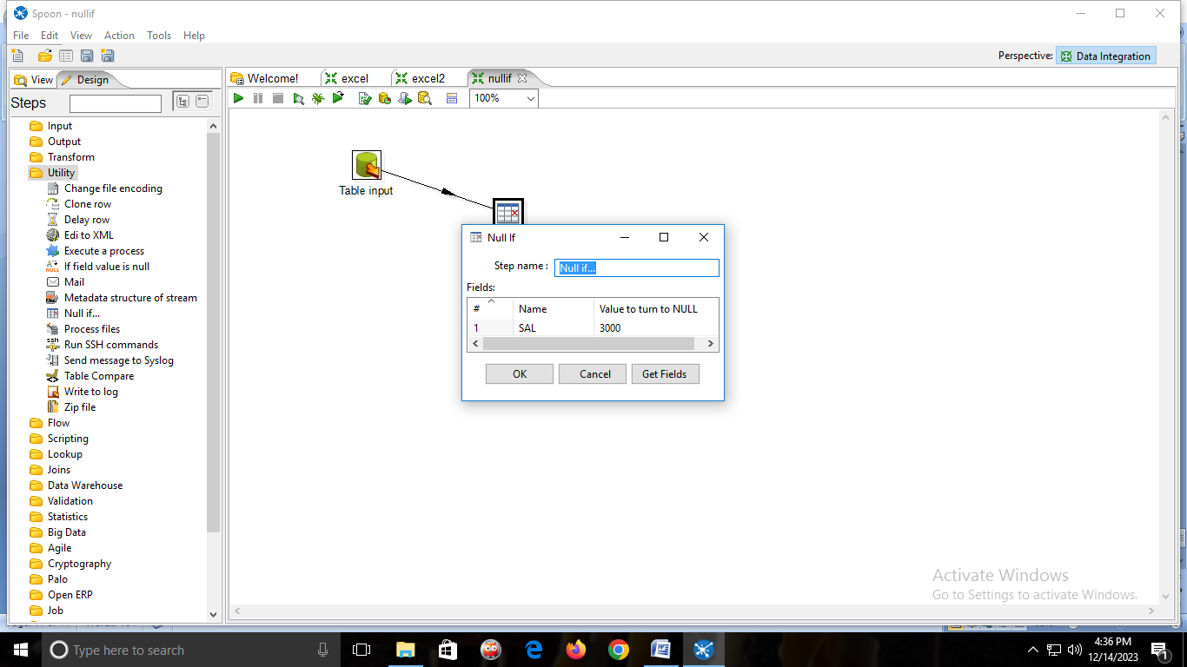

**OUTPUT:**

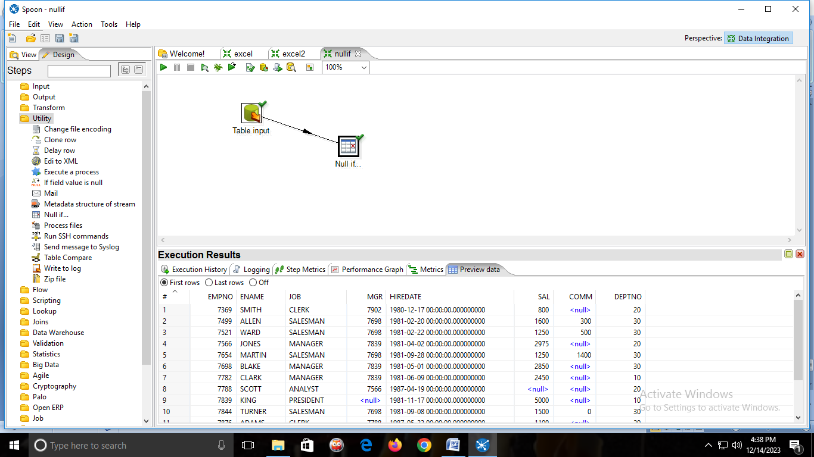

**FILTER.**

1)from input folder🡪drag & drop table input.



2)New🡪connection name



Click on🡪GET SQL SELECT STATEMENT🡪and select the table🡪then click on preview.



🡪Preview table



2)From Flow folder 🡪 drag & drop FILTER ROWS and connect table input to filter rows.

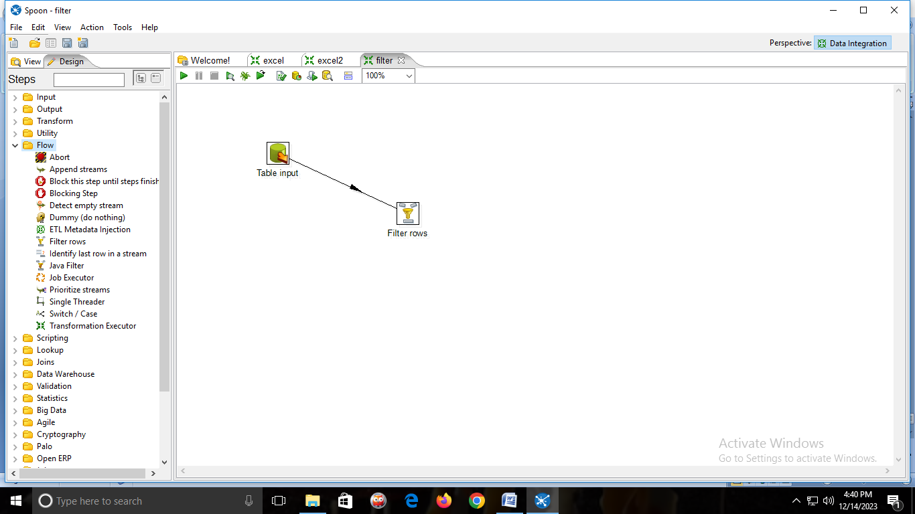

3)Double click on filter rows and fill the values and click on OK.

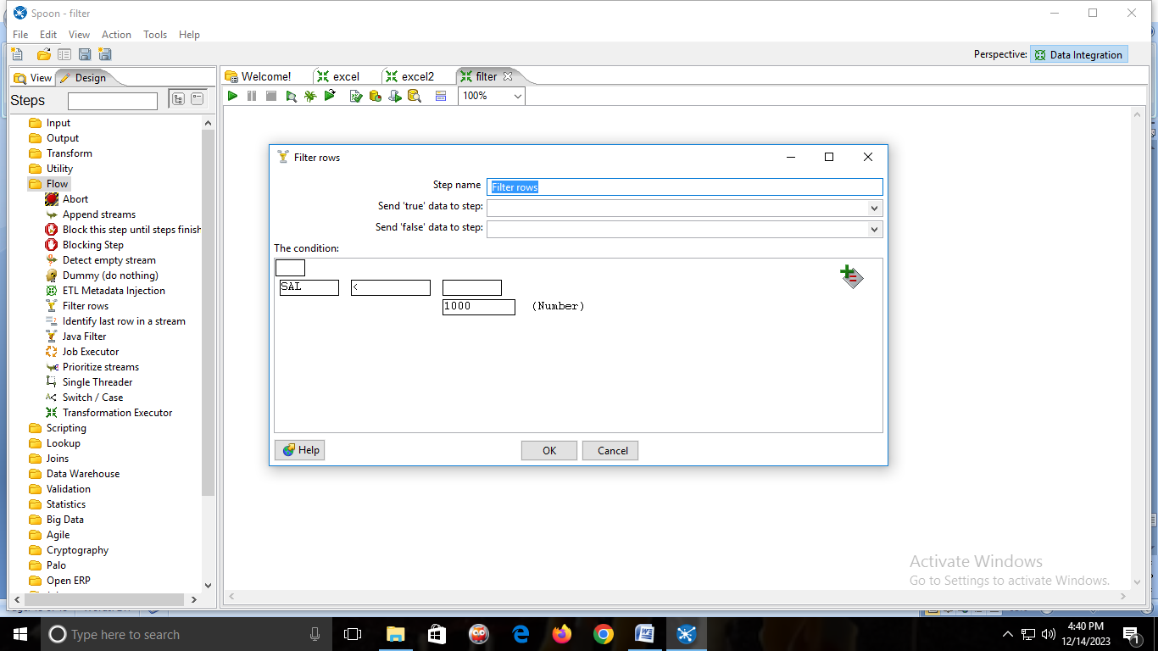

**OUTPUT:**

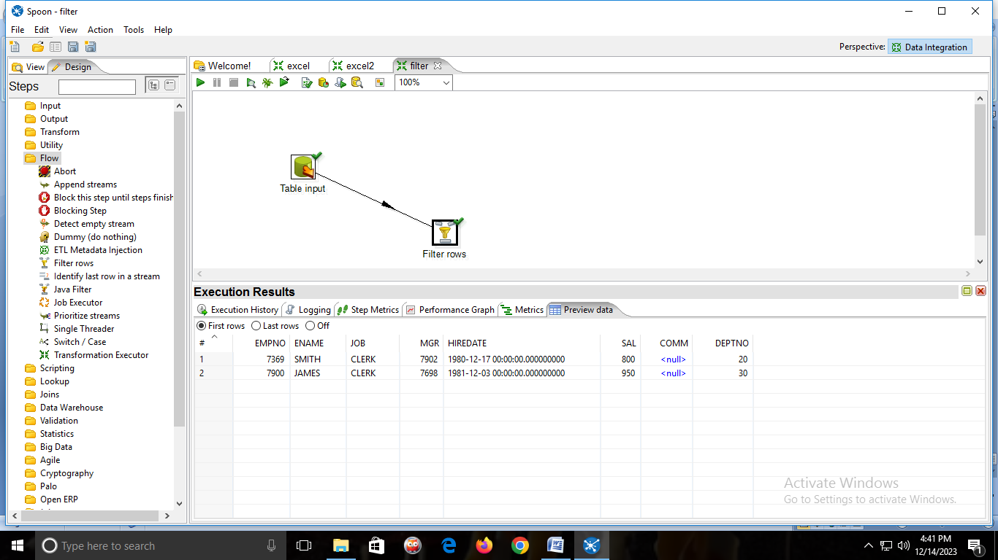

**Practical No:-7**

**Aim:-String Operations**

1)create an Excel sheet with the fields firstname,lastname,fullname,rollno,marks

2)From input folder🡪drag & drop🡪 MICROSOFT EXCEL INPUT

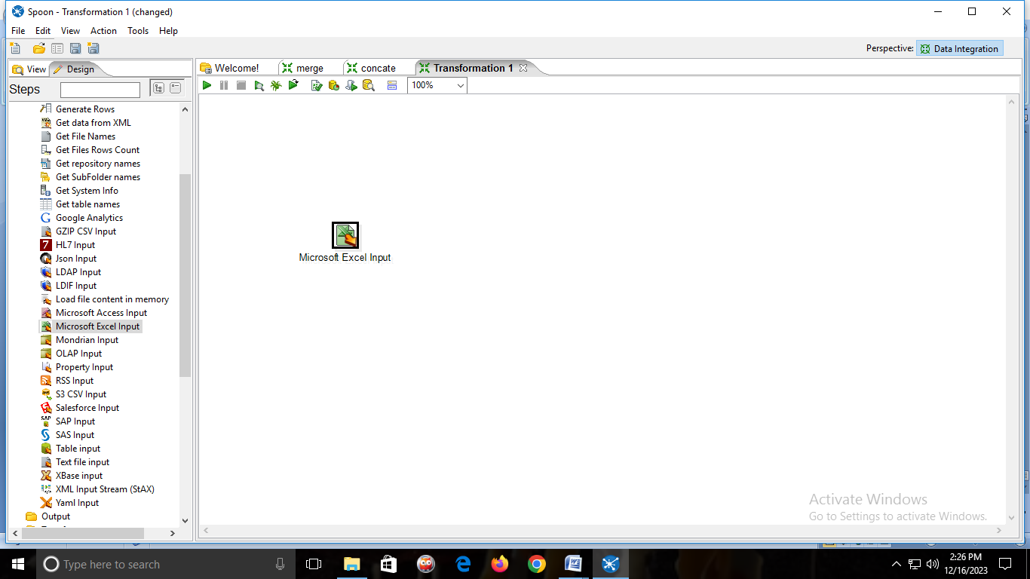🡪Double click on it and add the Excel sheet.

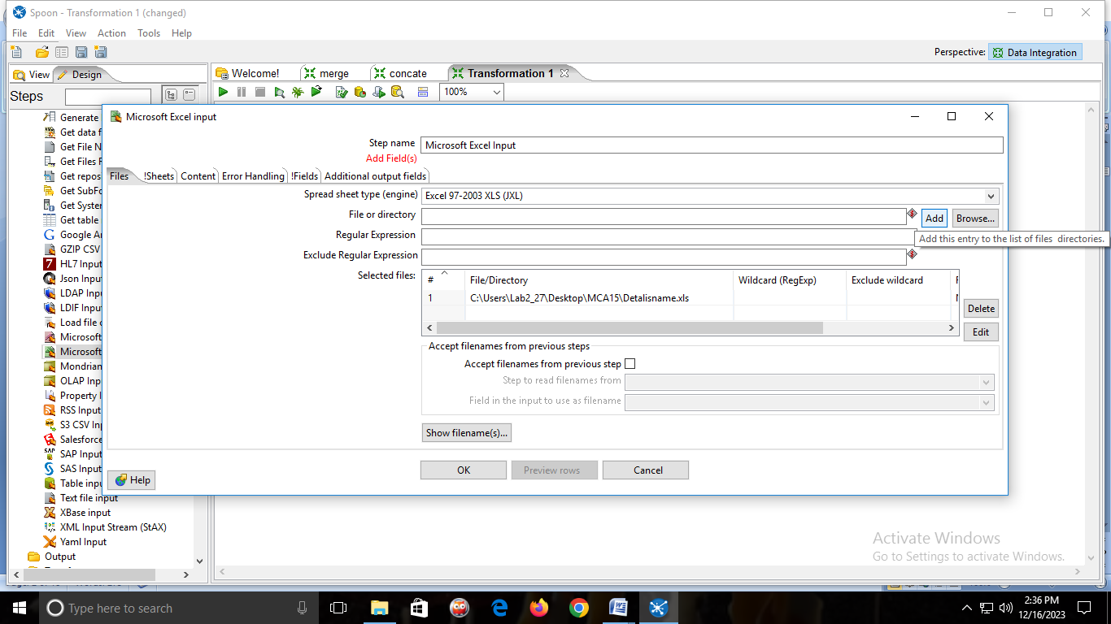

🡪click on get fields from header row

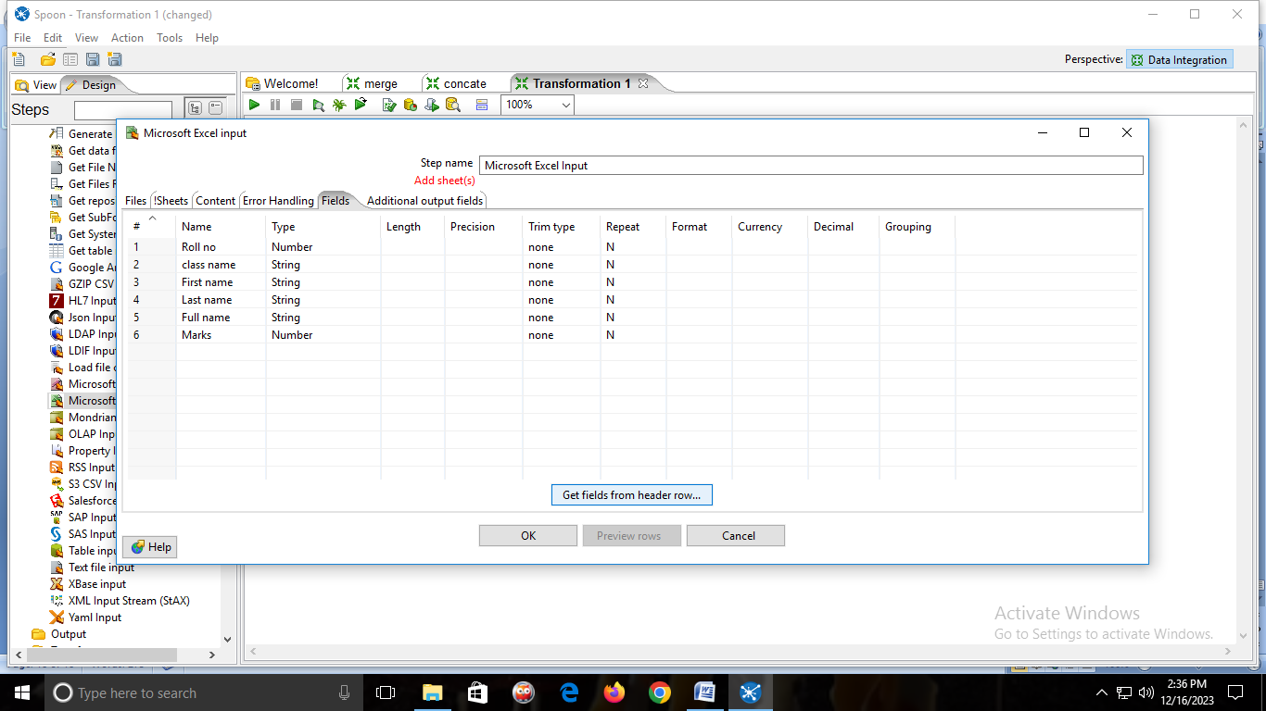

🡪then click on sheets🡪click on get sheetname🡪add sheet1🡪ok

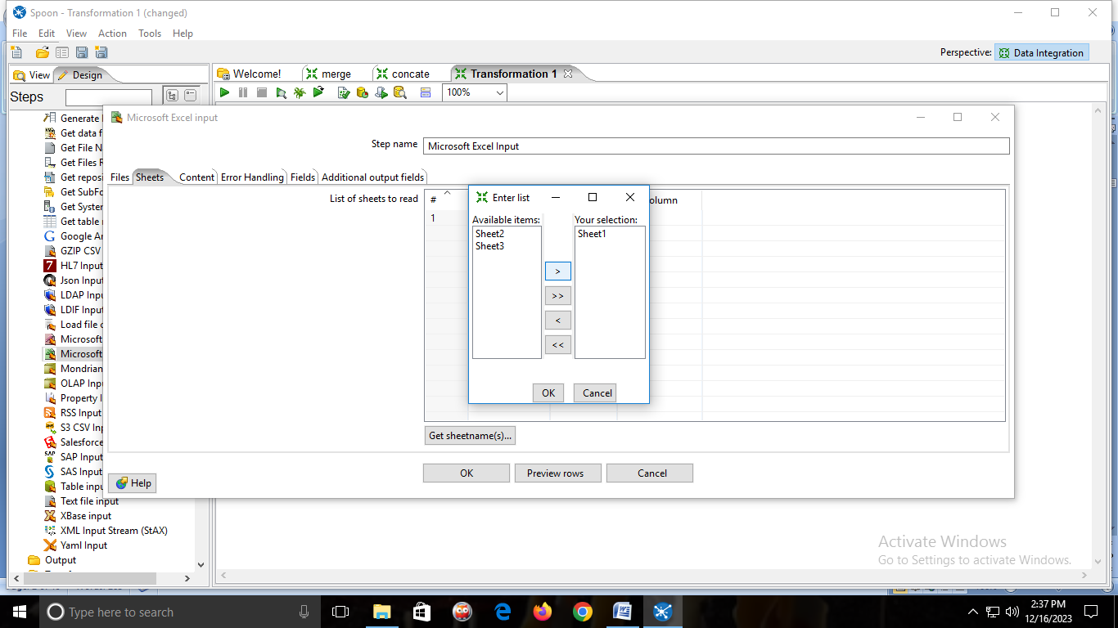

🡪click on Preview rows🡪Ok

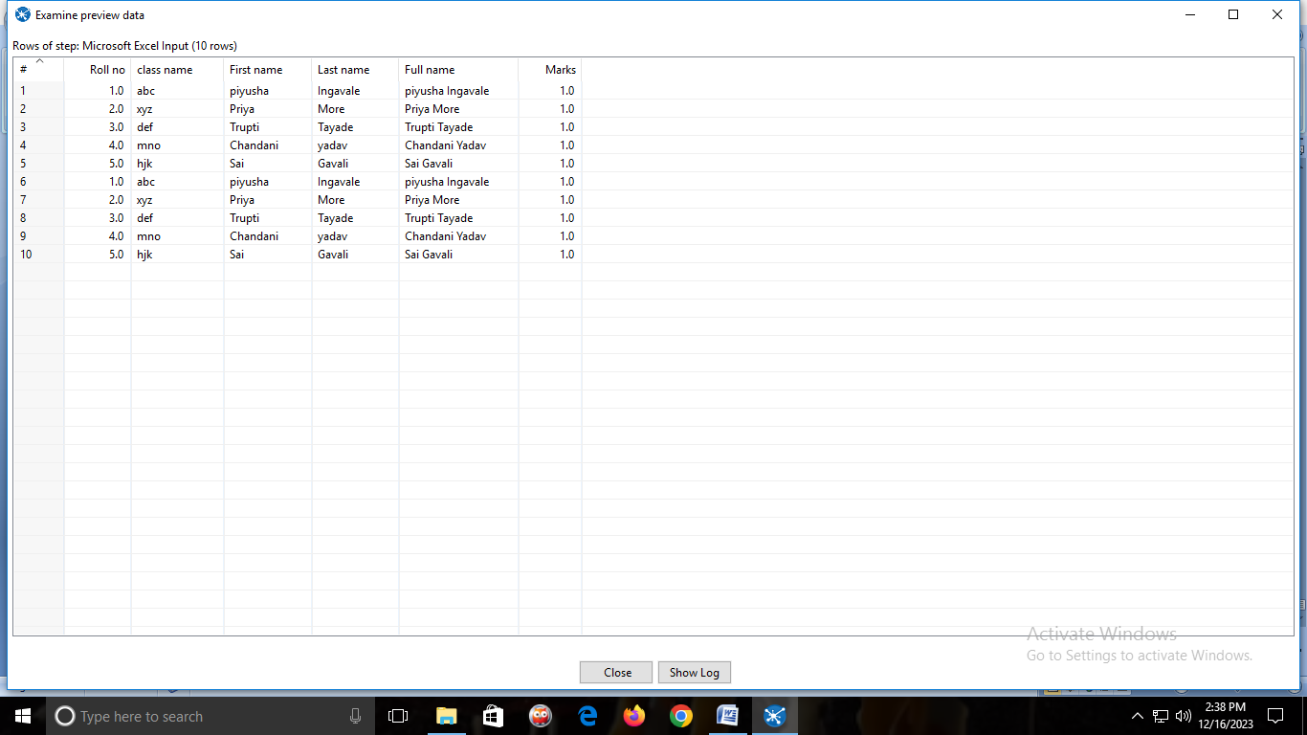

3)From Transform Folder🡪drag & drop🡪STRING OPERATIONS🡪and connect MICROSOFT EXCEL INPUT to STRING OPERATIONS.

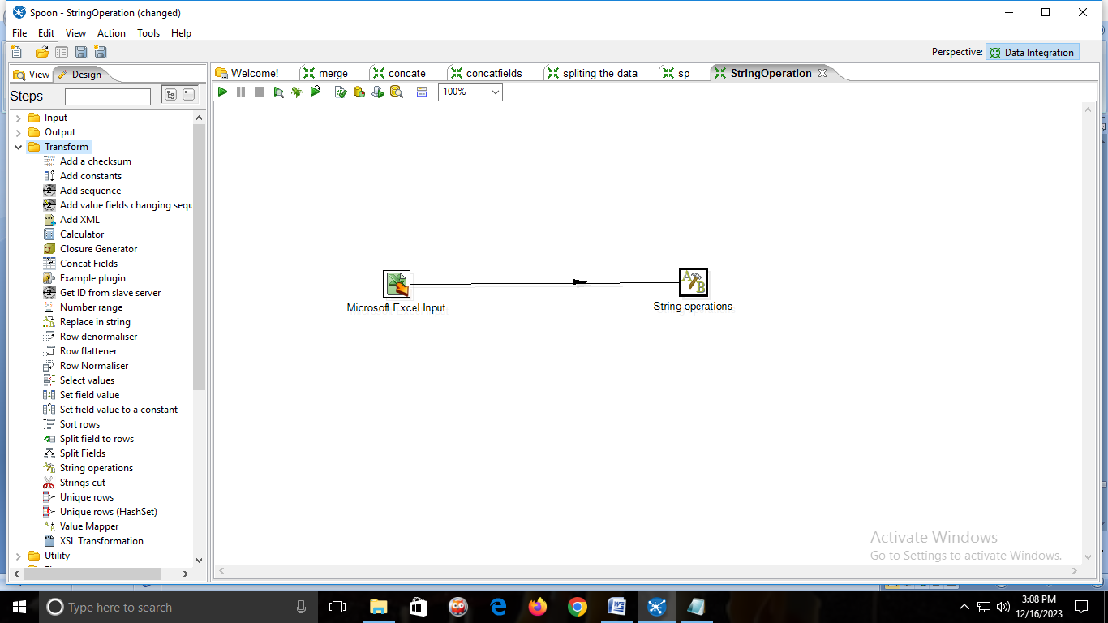

🡪double click on STRING OPERATIONS

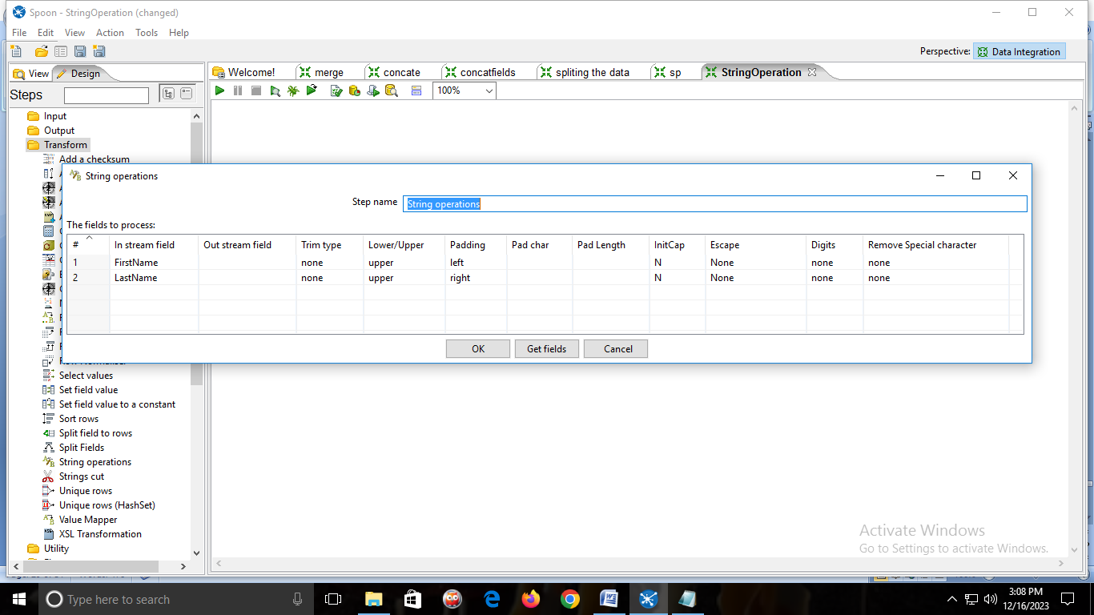

**OUTPUT:**

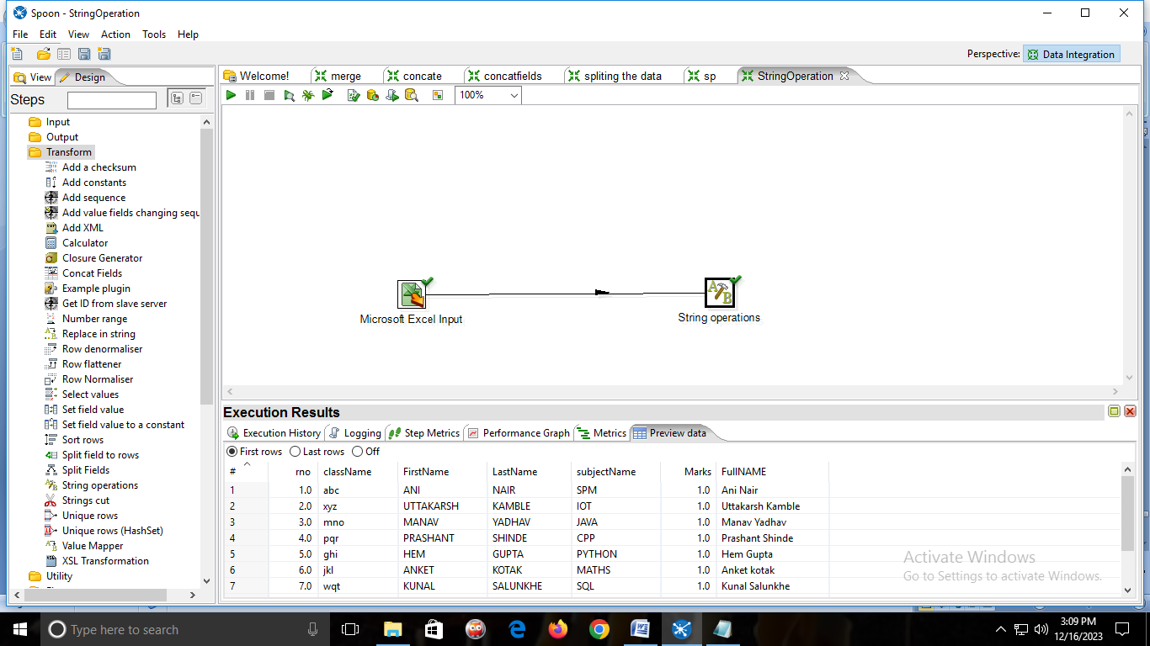

**F. Split**

1)create an Excel sheet with the fields firstname,lastname,fullname,rollno,marks

2)From input folder🡪drag & drop🡪 MICROSOFT EXCEL INPUT



🡪Double click on it and add the Excel sheet.



🡪click on get fields from header row



🡪then click on sheets🡪click on get sheetname🡪add sheet1🡪ok



🡪click on Preview rows🡪Ok



3)From Transform folder🡪drag & drop🡪SPLIT FIELDS🡪and connect MICROSOFT EXCEL INPUT to SPLIT FIELDS.

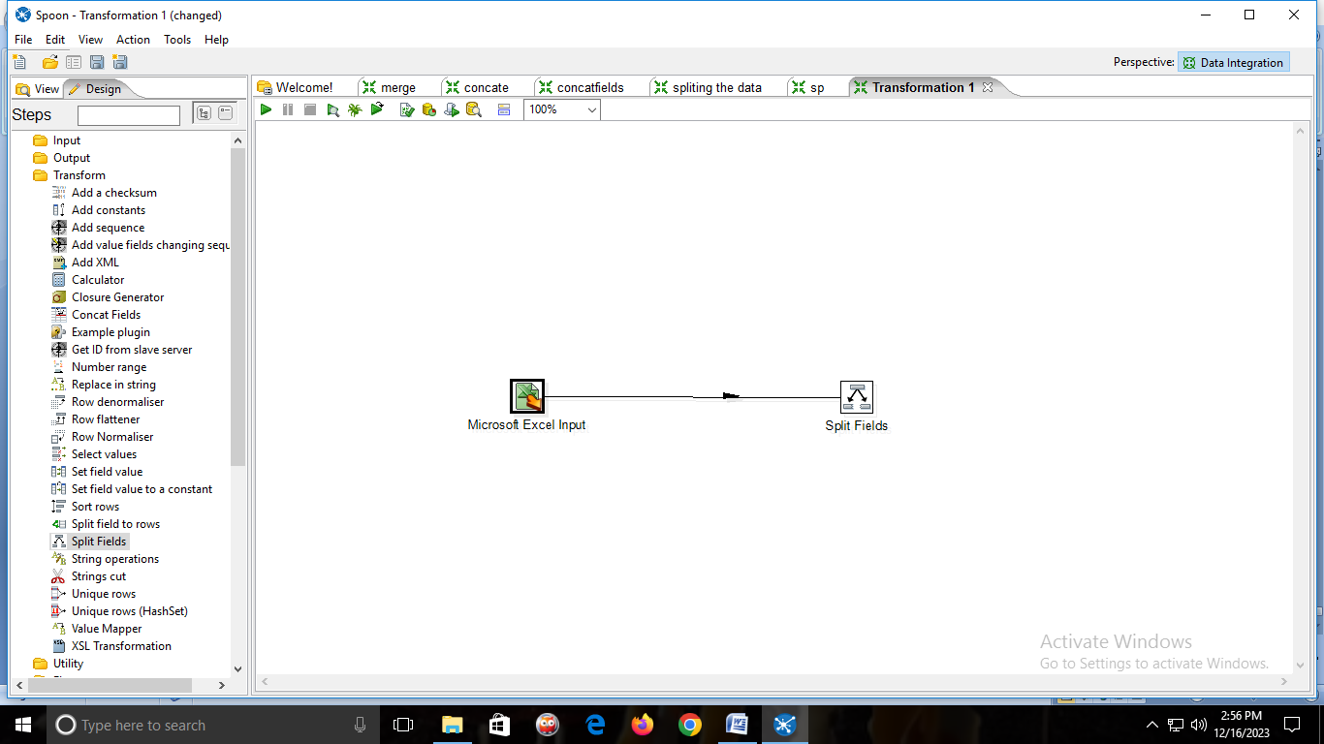

🡪Double click on SPLIT FIELD

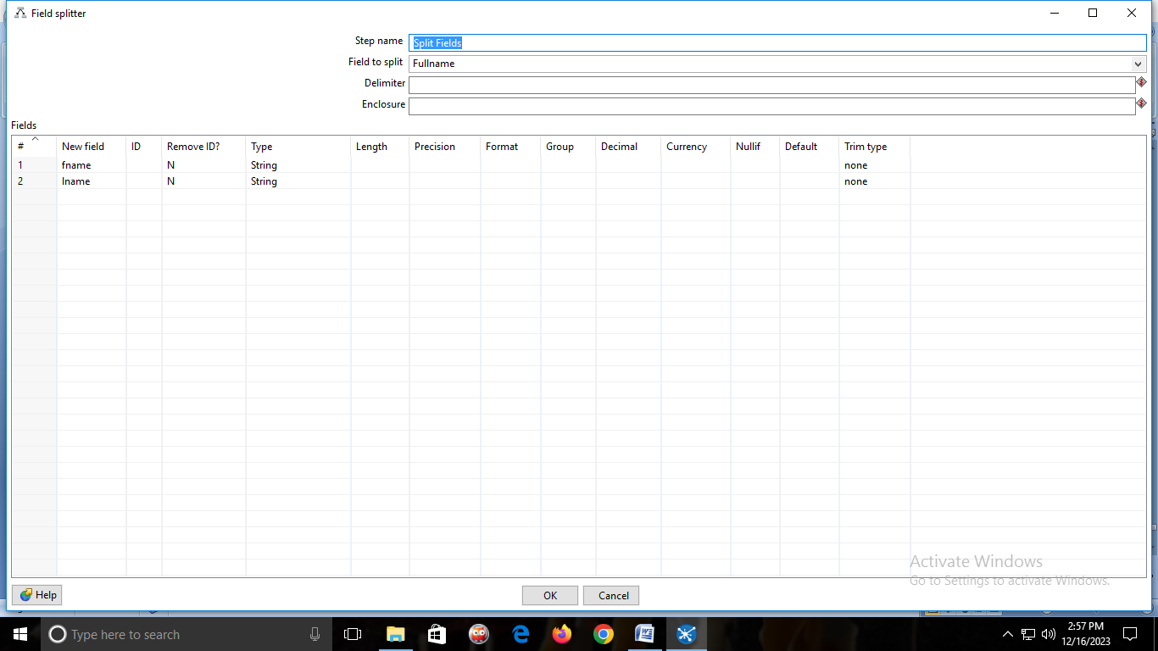

**OUTPUT:**



**G. Concatenation**

1)create an Excel sheet with the fields firstname,lastname,fullname,rollno,marks

2)From input folder🡪drag & drop🡪 MICROSOFT EXCEL INPUT



🡪Double click on it and add the Excel sheet.



🡪click on get fields from header row



🡪then click on sheets🡪click on get sheetname🡪add sheet1🡪ok

🡪click on Preview rows🡪Ok



3)from Transform folder🡪drag & drop🡪CONCAT FIELDS🡪and connect MICROSOFT EXCEL INPUT to CONCAT FIELDS.

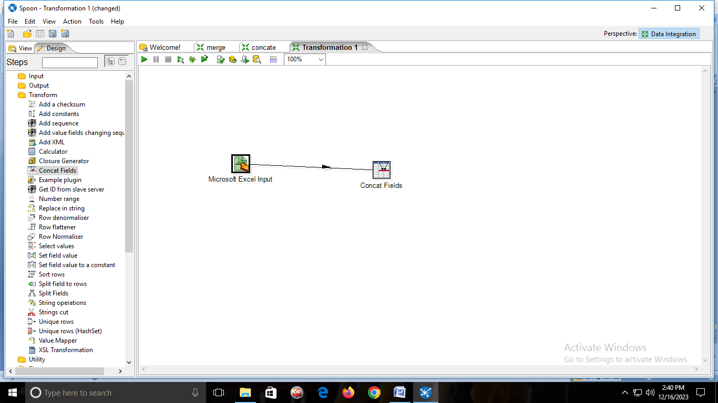

🡪double click on CONCAT FIELDS

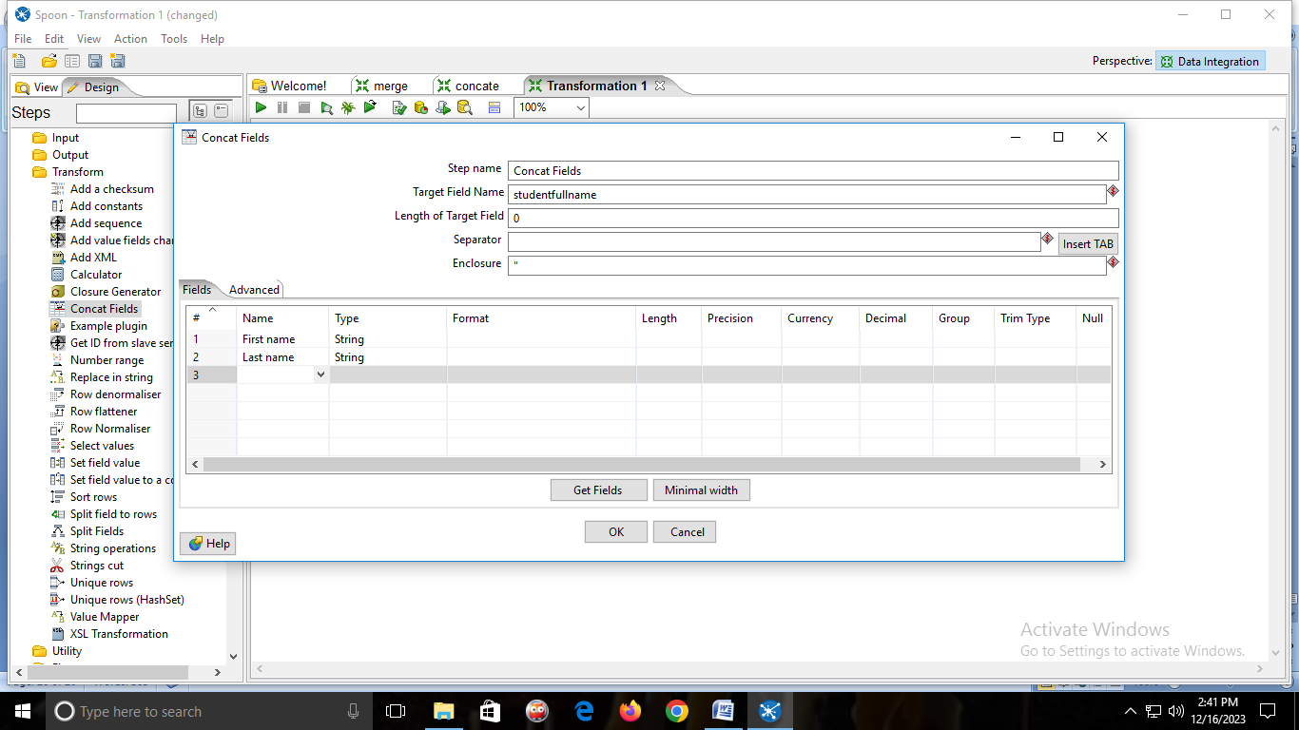

**OUTPUT:**

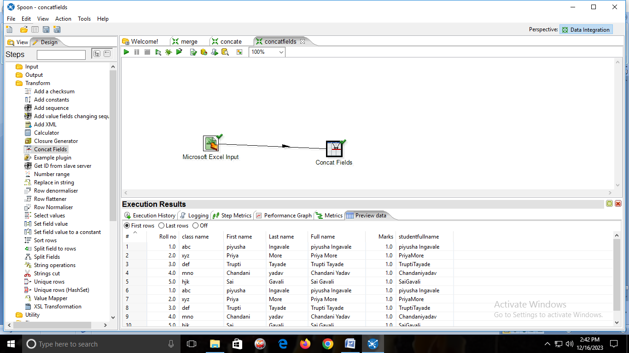

**h. Merge Join**

1)Create Two Excel Sheets with the fields Roll no and Marks. 🡪first Excel sheet will have roll no from 1-4 and Second Excel sheet will have roll no from 5-8.

Excel 1

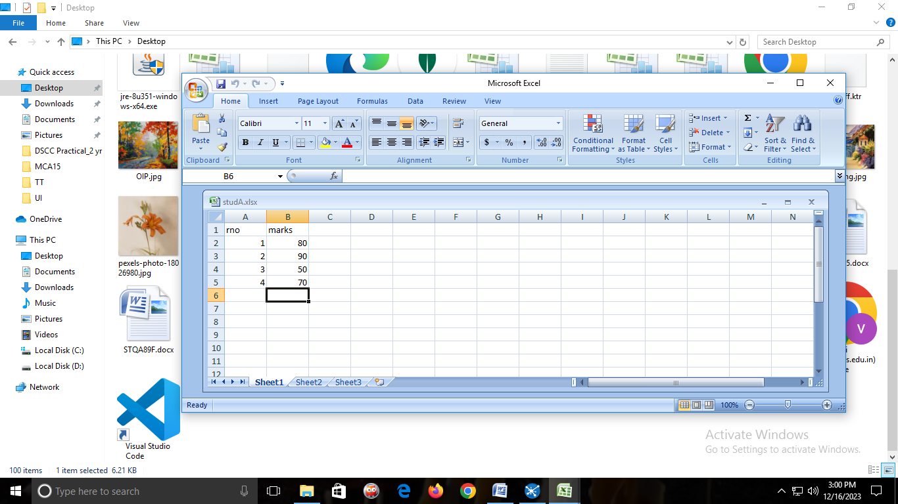

Excel 2

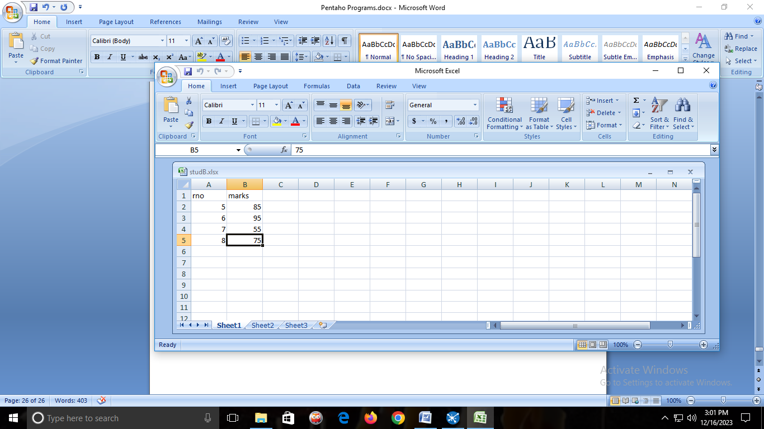

2)From input folder🡪drag & drop Two🡪 MICROSOFT EXCEL INPUT

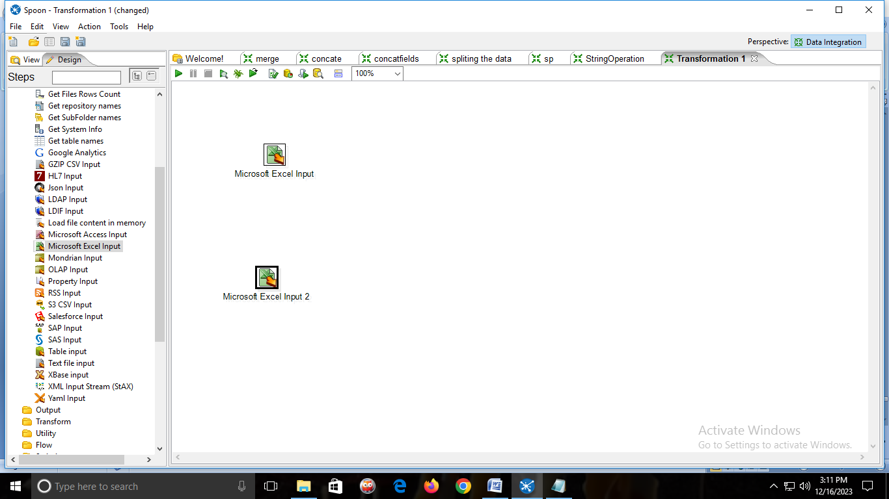

🡪Add the EXCEL file in both the INPUT FIELD.

🡪Double click on it and add the Excel sheet.

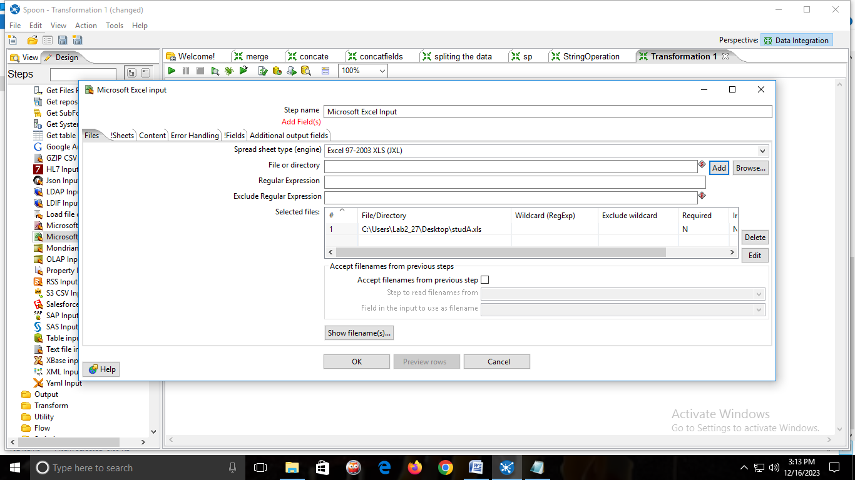

🡪click on get fields from header row

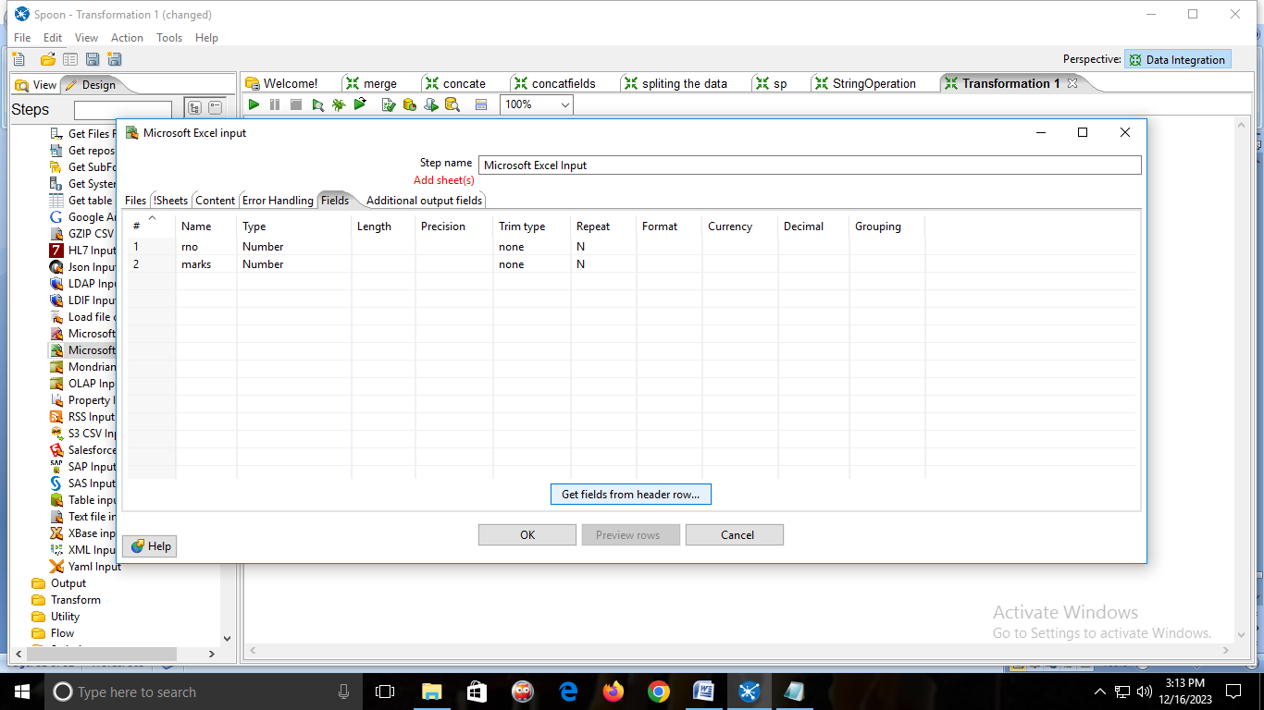

🡪then click on sheets🡪click on get sheetname🡪add sheet1🡪ok

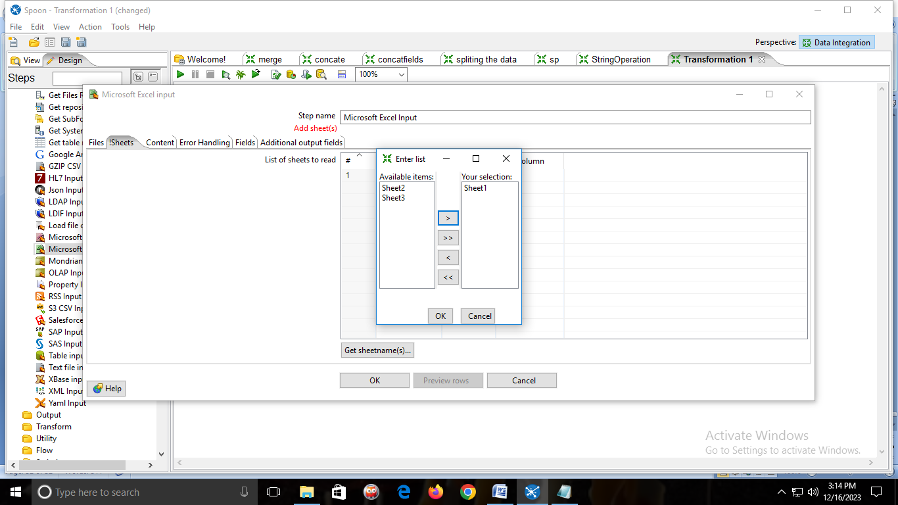

🡪click on Preview rows🡪Ok

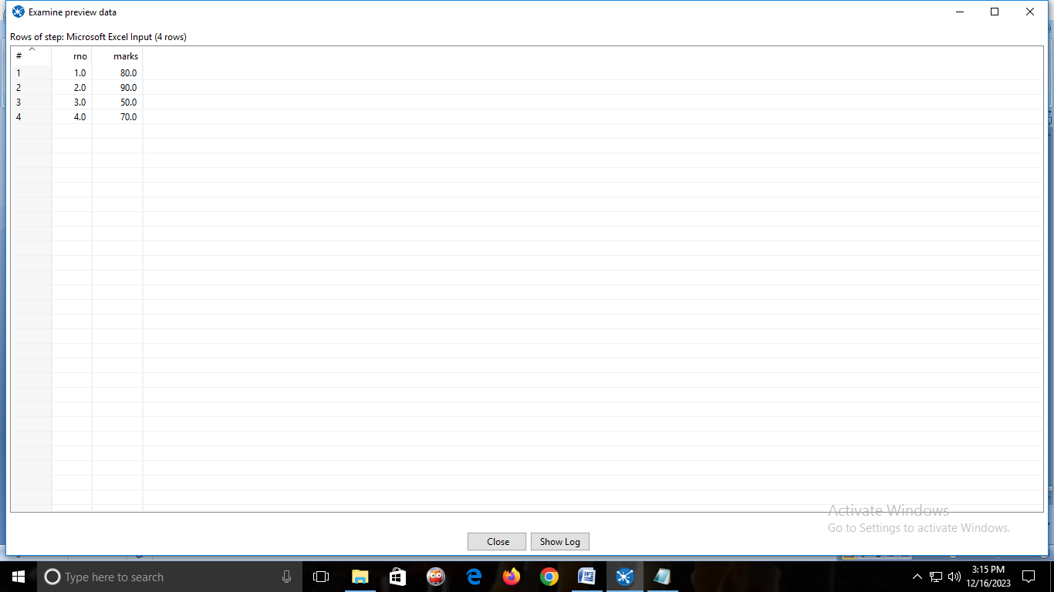

🡪Same process for the second Excel sheet.

3)From Transform folder🡪drag & drop Two🡪SORT ROWS.And connect it with MICROSOFT EXCEL INPUT.

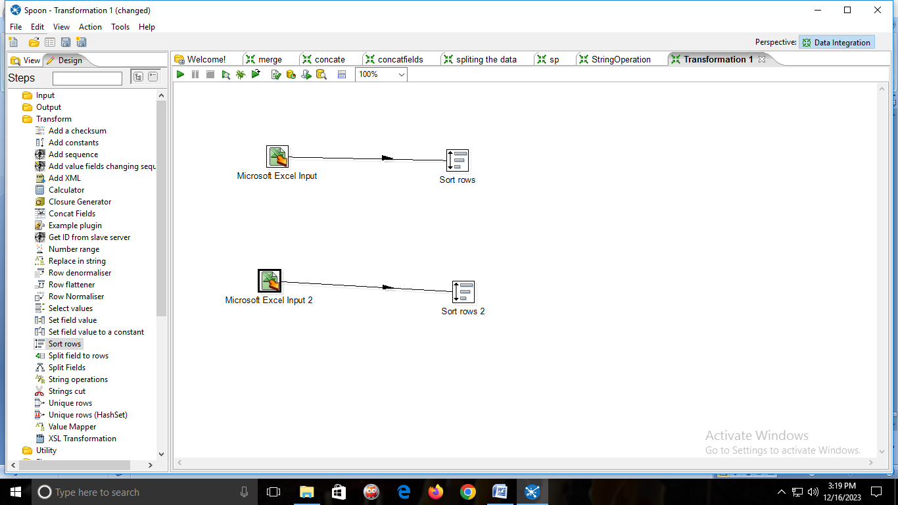

🡪Double click on Sort rows

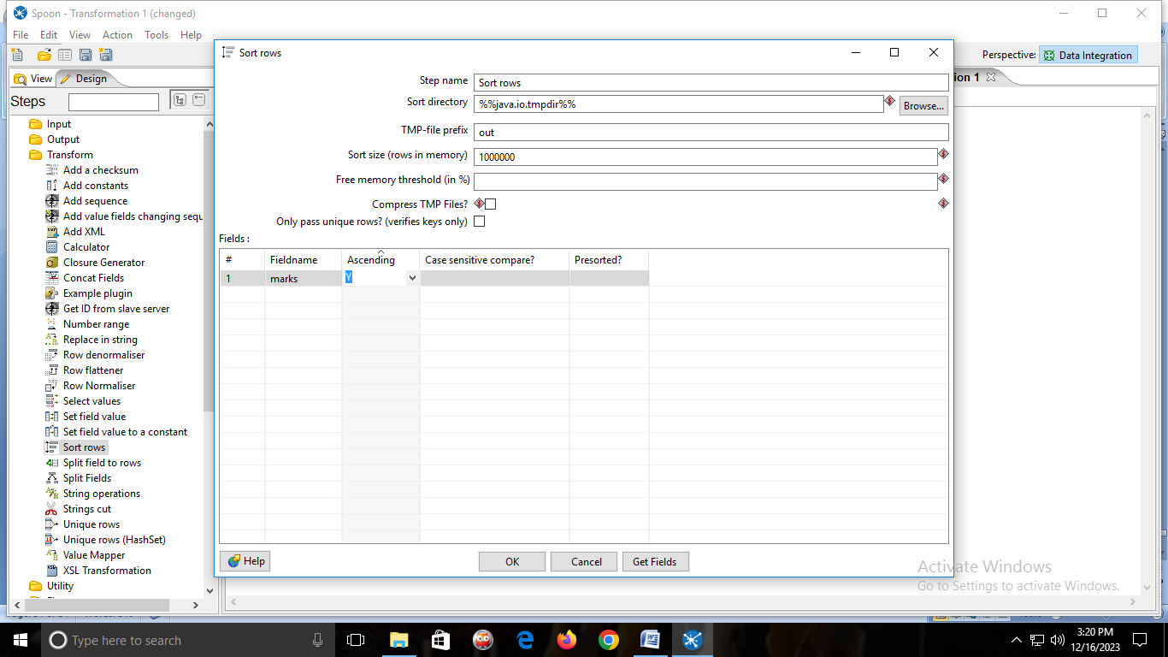

🡪Same for Second SORT ROWS.

4)from Join folder🡪drag & drop🡪MERGE JOIN. And connect it with both the SORT ROWS.

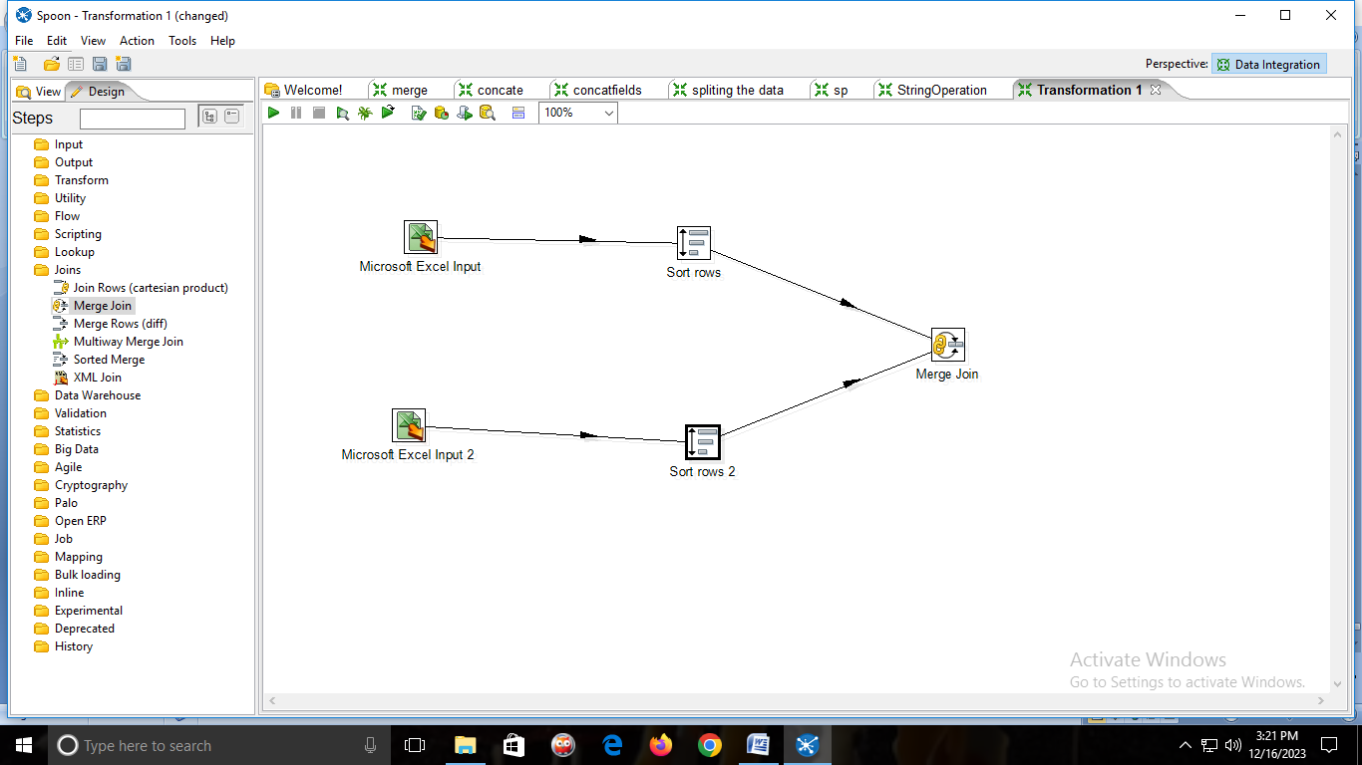

🡪double click MERGE JOIN

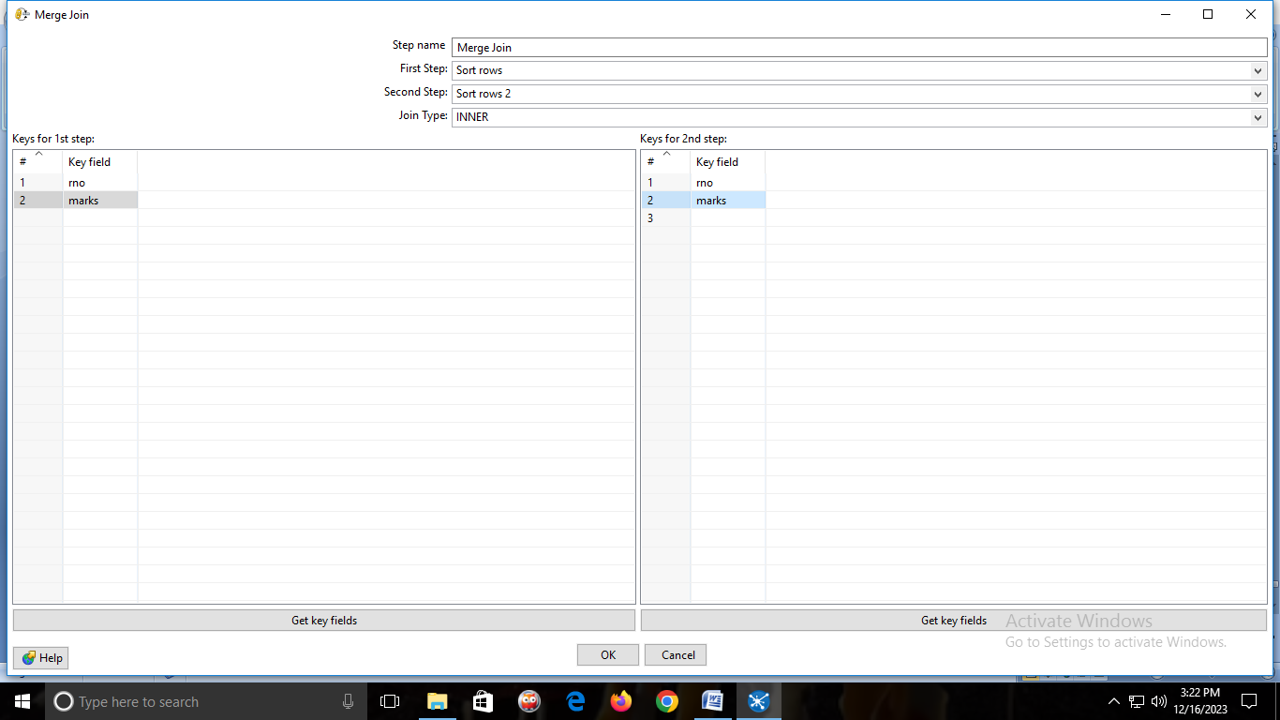

**OUTPUT:**

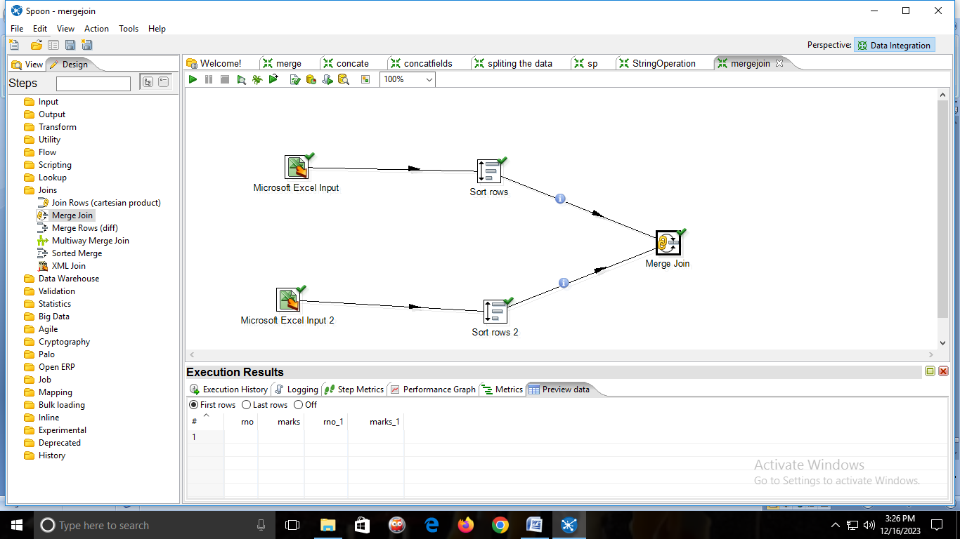

**PRACTICAL NO: 08**

**AIM:Implementation at basic R commands and Data acquisition.**

**Code:-**

myString <-"Hello World"

print(myString)

myString="Disha"

print(myString)

Output:-

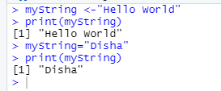

Code:-

setwd("C:/R Orientation")

getwd()

O/p:-

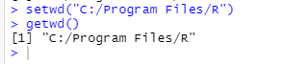

Code:-

dir()

ls()

x<-7

class(x)

O/p:-

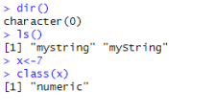

Code:-

y="Disha"

class(y)

"character"

print(y)

"Disha"

O/p:-

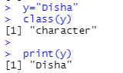

Code:-

p=10

is.integer(x)

O/p:-

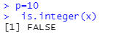

Code:-

q=9.5

as.integer(q)

is.character(q)

O/p:-

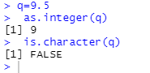

Code:-

#creating a vector

a=c("Dipti","Prachi")

a=c("Disha","Chirantan","Sweetu")

q=vector("logical",length=5)

length(q)

print(q)

O/p:-

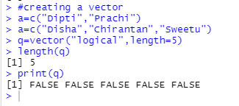

Code:-

y=c(3,4,5)

y*9

a=c(9,5,7)

a+5

b=c(7,8,4.6)

b-10

n=c(91,68,27)

n/5

O/p:-

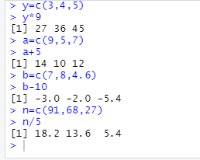

Code:-

m=matrix(c(8,9,5,4),nrow = 4,ncol = 4)

dim(m)

m=matrix(c(8,9,5,4),nrow = 4,ncol = 4)

print(m)

O/p:-

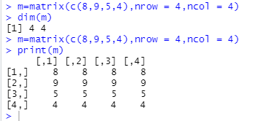

Code:-

m=matrix(c(9,5,4,2),nrow = 4,ncol = 4,byrow = TRUE)

dim(m)

a=4

b=5

cbind(a,b)

rbind(a,b)

O/p:-

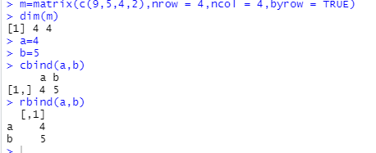

**PRACTICAL NO: 09**

**AIM:- Implementation of Data Pre-processing**

**Code:**

#read csv file

data = read.csv("B:/R-lab/mtcars.csv")

data

#slicing

mydata = data[1:6,1:5]

mydata

#rename column

install.packages("dplyr")

require(dplyr)

mydata1 = rename(data,horse_power=hp)

mydata1

#adding a new variable into the data set

mydata1$new_hp = mydata1$horse_power*2

mydata1

colnames(mydata1)

#basic pre processing

##creation of vector

v = c(3,4,NA,5)

v

##median of vector v and removal of null value

median(v, na.rm = T)

v

##check for null value in vector

naValues = is.na(v)

naValues

##vector without null value

v[!naValues]

v[complete.cases(v)]

###READING A CSV FILE USING R STUDIO

data=read.csv("B:/R-lab/studentinfo.csv")

data

dataT<-read.table("B:/R-lab/studentinfo.csv",sep=",",header=T)

dataT

###WRITING CONTENTS TO CSV AND EXCEL FILES

install.packages("XLConnect")

install.packages("writexl")

install.packages("readxl")

library(XLConnect)

library(writexl)

library(readxl)

dataN=data.frame(a=5,b=10,c=4)

dataN

write.csv(dataN,file="dataN.csv")

#imputation

install.packages("Hmisc")

library(Hmisc)

##creation of vector

x = c(1,2,3,NA,4,4,NA)

##mean from vector

x = impute(x,fun=mean)

x

##median from vector

x = impute(x,fun=median)

x

##CATEGORICAL DATA: CREATION OF VECTOR

gender_vector=c("FEMALE","MALE",NA,"FEMALE","FEMALE")

class(gender_vector)

###convert vector to factor

factor_gen_v = factor(gender_vector)

class(factor_gen_v)

m = impute(factor_gen_v, fun=mode)

m

**OUTPUT:**

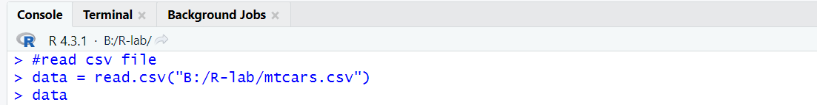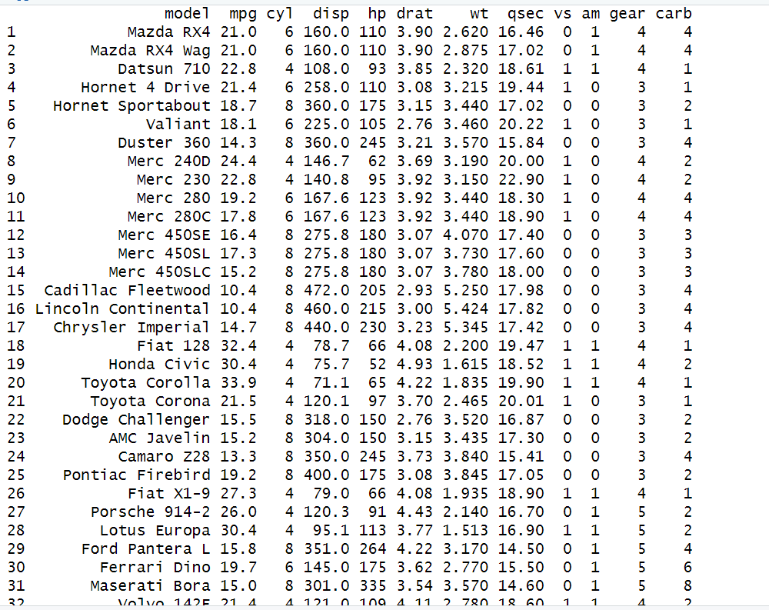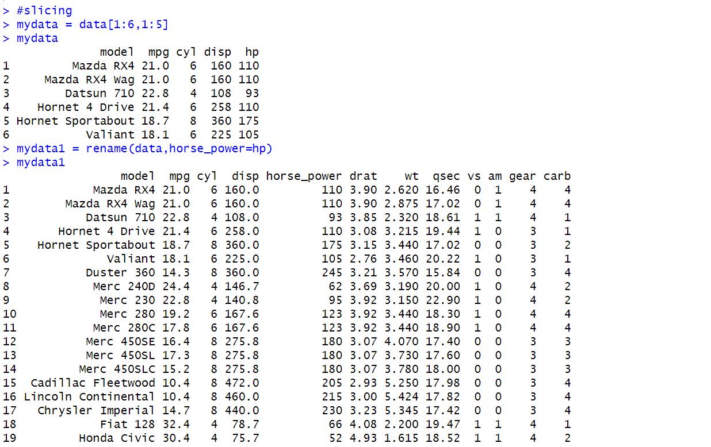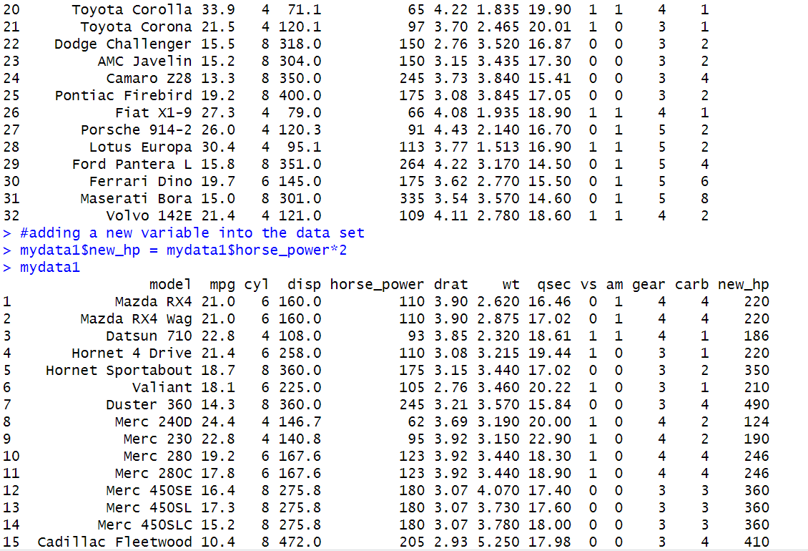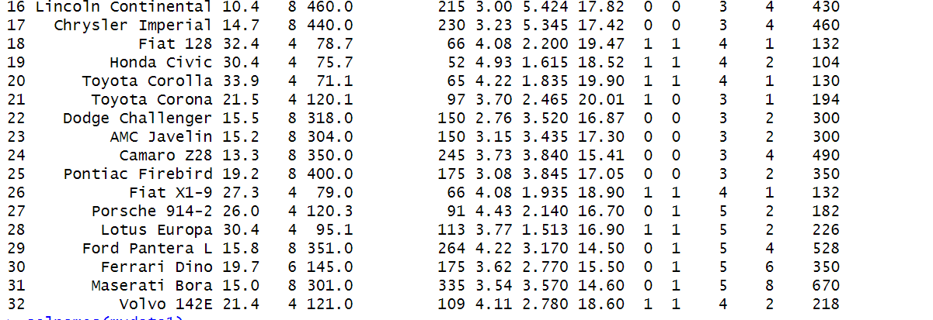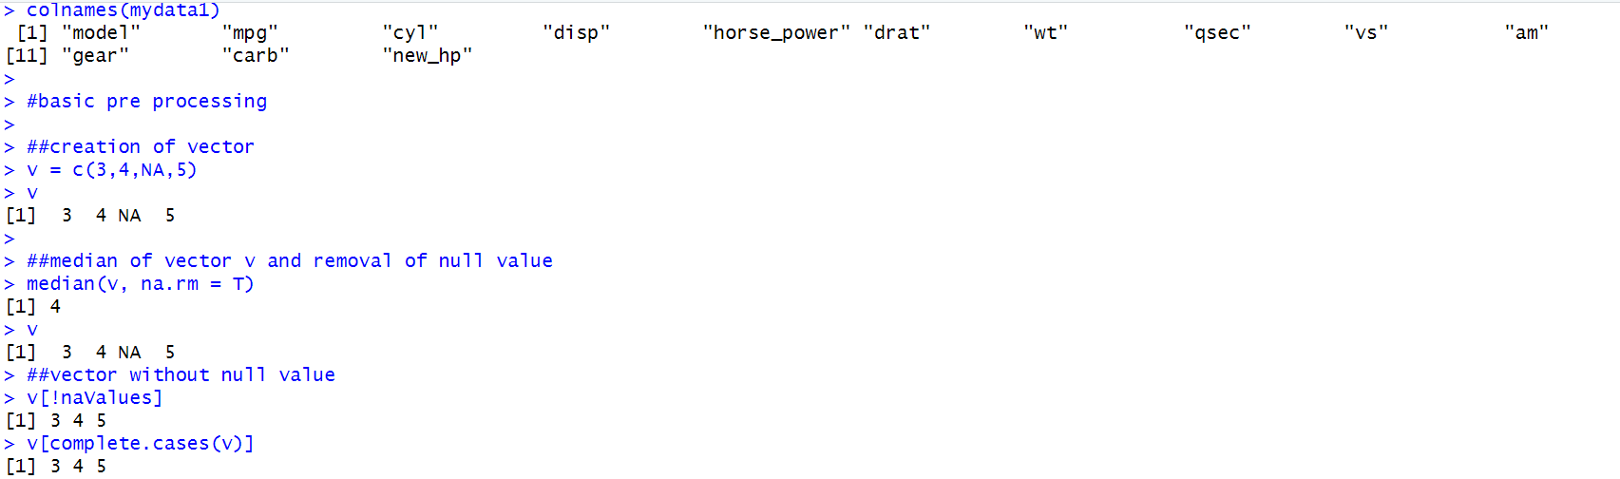

**Practical No:-10**

**Aim:-Data Mining: Classification Using Naive-Bayes Algorithm**

**CODE:**

install.packages("e1071")

library(e1071)

install.packages("MASS")

install.packages("lattice")

install.packages("ggplot2")

install.packages("klaR")

library(klaR)

install.packages("caret")

library("caret")

data=read.csv("B:/R-lab/iris1.csv")

head(data)

unique(data$Species)

index=sample(nrow(data),floor(nrow(data)*0.7))

train1=data[index,]

head(train1)

test=data[-index,]

xtrain1=train1[,-5]

ytrain1=train1$Species

xtest=test[,-5]

ytest=test$Species

train_control= trainControl(method='cv',number=10)

model = train(xtrain1,ytrain1,'nb',trControl=train_control)

model

prop.table(table(predict(model$finalModel,xtest)$class,ytest))

**OUTPUT:**

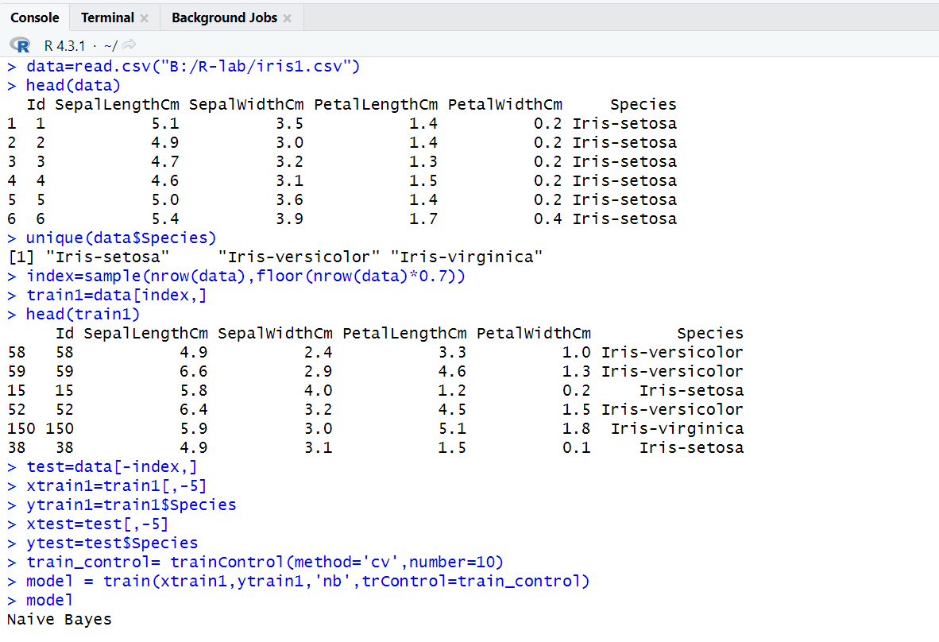

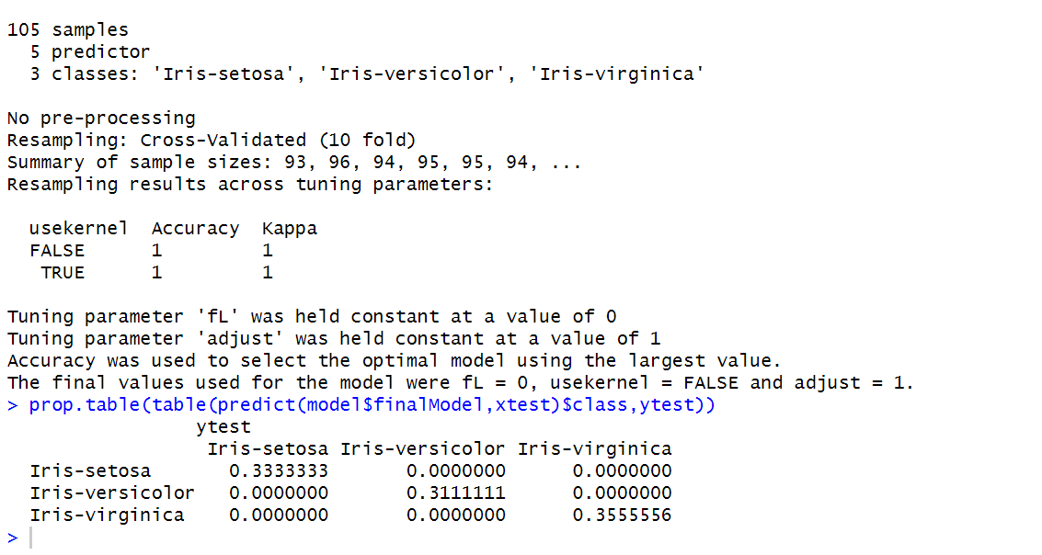

**Practical No:-11**

**Aim:-Classification- (KNN) Knowledge Nears Neighbor Algorithm.**

**CODE:**

data=read.csv("B:/R-lab/iris1.csv")

data

head(data)

ran=sample(1:nrow(iris),0.9*nrow(iris))

ran

nor=function(x){(x-min(x)/(max(x)-min(x)))}

iris_norm=as.data.frame(lapply(iris[,c(1,2,3,4)],nor))

summary(iris_norm)

##Exctract Training set

iris_train<-iris_norm[ran,]

dim(iris_train)

##Exctract Testing Set

iris_test=iris_norm[-ran,]

dim(iris_test)

#Extract 5th coloumn of train dataset because it will be used as 'cl' argument knn function

iris_target_category=iris[ran,5]

#exctract 5th coloumn if test dataset

#to measure the accuracy

iris_test_category=iris[-ran,5]

#load the package class

installed.packages("class")

library(class)

#run knn function

#viva k mean clustering

#knn k = classification (number of nearer records)

#pr = prediction

pr=knn(iris_train,iris_test,cl=iris_target_category,k=13)

##create confusion matrix`(used for measure accuracy)

tab=table(pr,iris_test_category)

tab

##prediction that tell us how accurate model is

accuracy=function(x){sum(diag(x)/(sum(rowSums(x))))*100}

accuracy(tab)

**OUTPUT:**

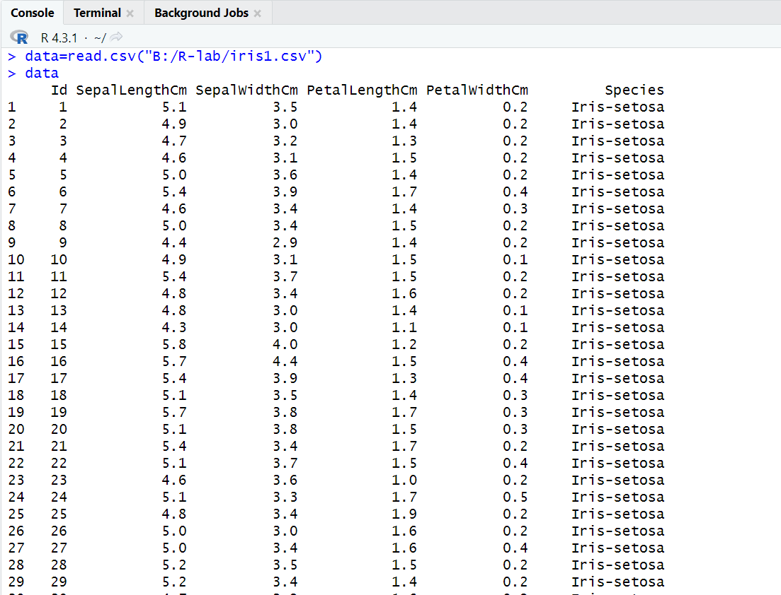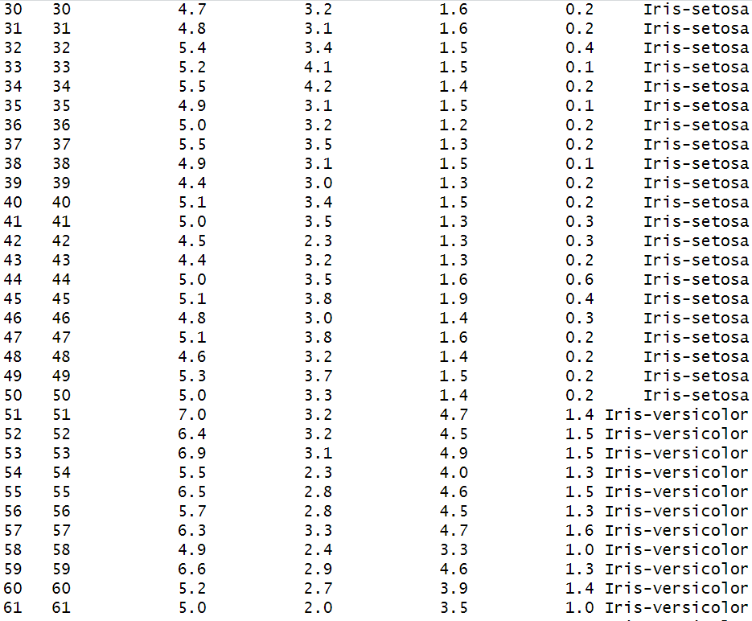

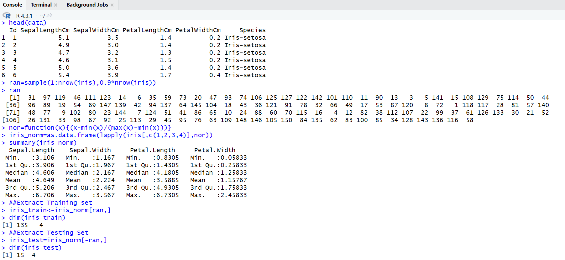

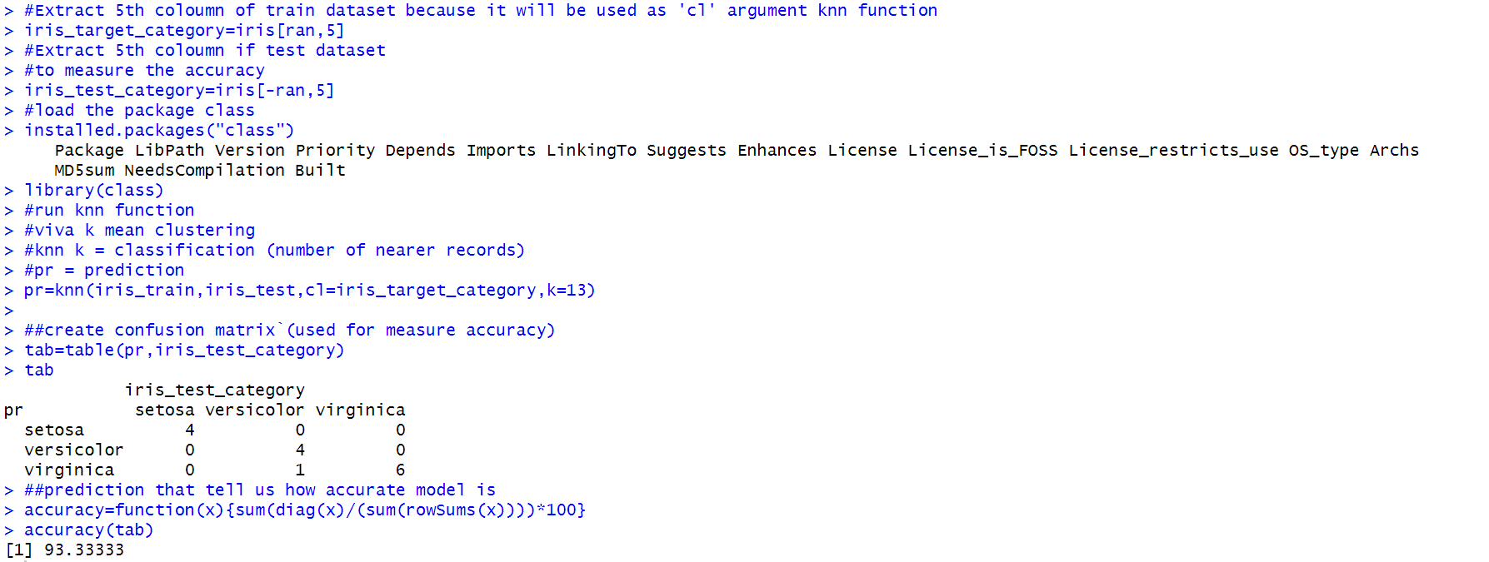

**Practical No:-12**

**Aim:-Decision Tree**

**Code:-**

data(iris)

dim(iris)

str(iris)

set.seed(789)

#sample data 70% for training and 30% testing

sampled.data <- sample(2,nrow(iris),replace=TRUE,prob=c(0.7,0.3))

head(sampled.data)

tail(sampled.data)

trainData <-iris[sampled.data == 1,]

dim(trainData)

testData <- iris[sampled.data ==2,]

dim(testData)

install.packages("party")

library(party)

#Task is to predict the species class given all other variables

myFormula <- Species ~ Sepal.Length + Sepal.Width + Petal.Length + Petal.Width

#ctree() function from party package builds the decision tree model

iris_ctree <- ctree(myFormula,data=trainData)

#predict() function predict the class label

table(predict(iris_ctree), trainData$Species)

plot(iris_ctree)

plot(iris_ctree, type="simple")

#now predict classification on test data

iris_ctree_1<- ctree(myFormula,data = testData)

table(predict(iris_ctree_1),testData$Species)

plot(iris_ctree_1,type="simple")

testPred <- predict(iris_ctree, newdata = testData)

tab = table(testPred,testData$Species)

accuracy<-function(x){sum(diag(x)/sum(rowSums(x)))*100}

accuracy(tab)

accuracy(tab_train)

**Output:-**

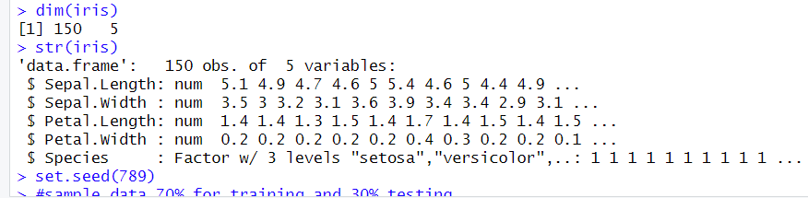

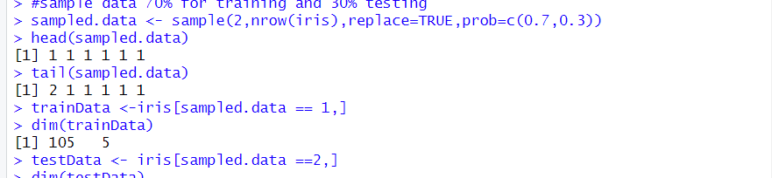

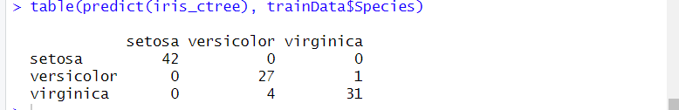

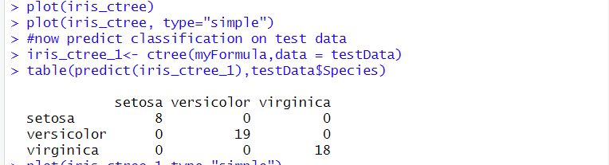

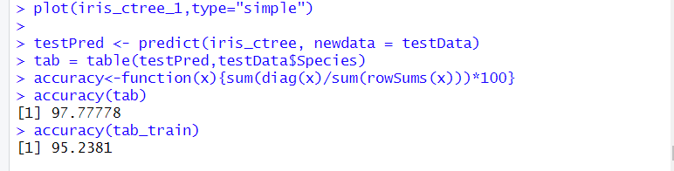

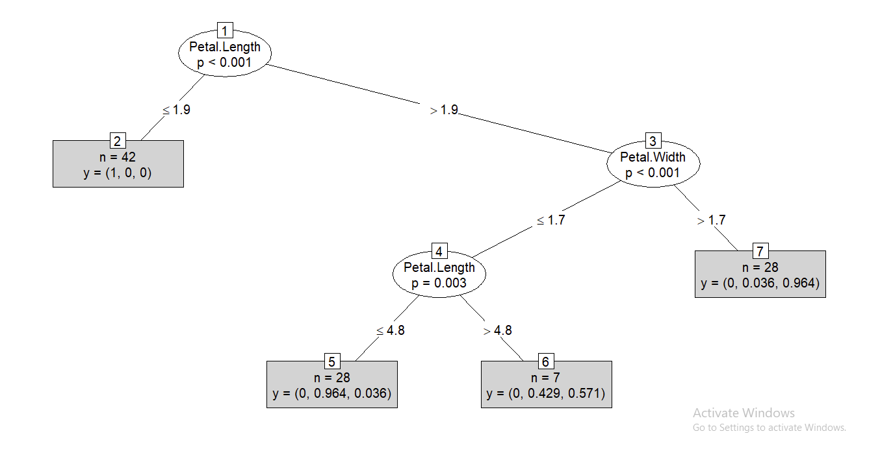

**Practical No:- 13**

**Aim:-Apriori Algorithm-Market Basket Analysis.**

**CODE:**

#Apriori algorithm for association rule mine (market basket analysis)

data=read.csv("B:/R-lab/data_apriori.csv")

data

trans=split(data$Products,data$Customer_Id,"transactions")

head(trans)

#loading arules library

install.packages("arules")

library(arules)

rules=apriori(trans,parameter = list(support=0.5,confidence=0.9,maxlen=3,minlen=2))

#to get the rules

inspect(rules)

**OUTPUT:**

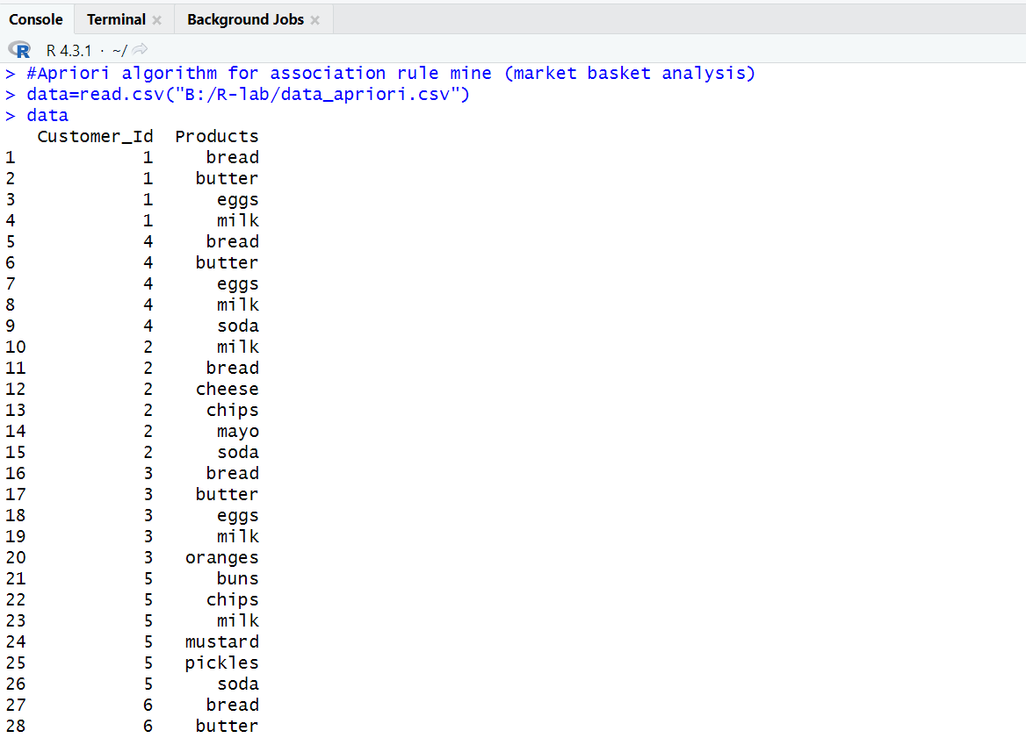

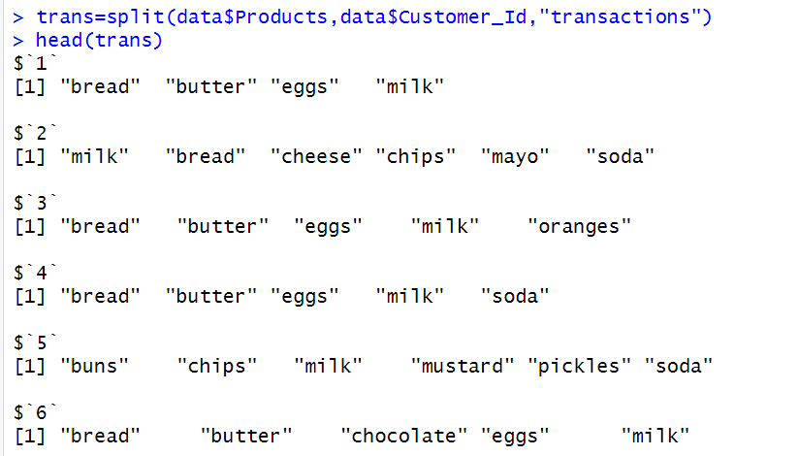

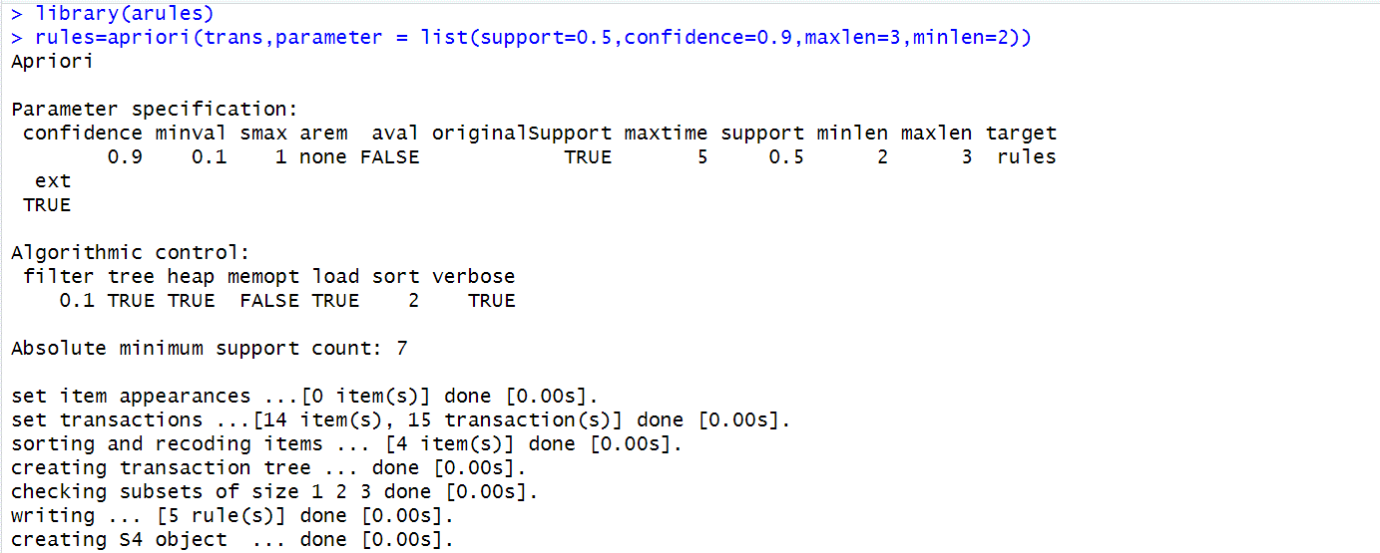

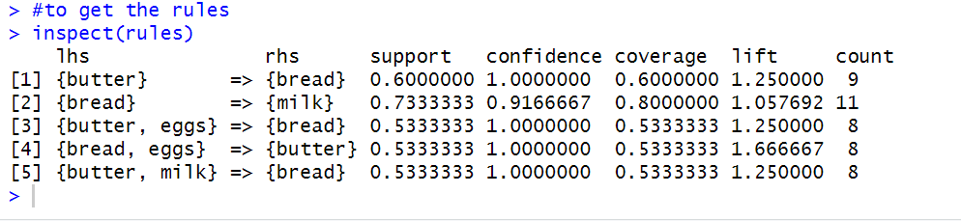

**Practical No:- 14**

**Aim:-Linear Regression.**

**CODE:**

library(ggplot2)

my_data=read.csv("E:/Sterling /20TH-OCT-2023/mtcars.csv")

names(my_data)

dim(my_data)

#randomize

my_data = my_data[sample(nrow(my_data),),]

head(my_data)

TrainData= my_data[1:20,]

TestData= my_data[21:32,]

#Linear Model

fit= lm(mpg~hp,data=mtcars)

summary(fit)

preds= predict(fit,newdata=TestData)

df1= data.frame(preds,TestData$mpg)

head(df1)

#correlation

cor(preds,TestData$mpg)

plot(mtcars$hp,mtcars$mpg)

#Better Model

lmmodel1= lm(mpg~hp+cyl+gear+wt, data=TrainData)

summary(lmmodel1)

preds_new= predict(lmmodel1,newdata=TestData)

df2= data.frame(preds_new,TestData$mpg)

head(df2)

cor(preds_new,TestData$mpg)

plot(mtcars$hp+mtcars$cyl+mtcars$gear+mtcars$wt,mtcars$mpg)

**OUTPUT:**

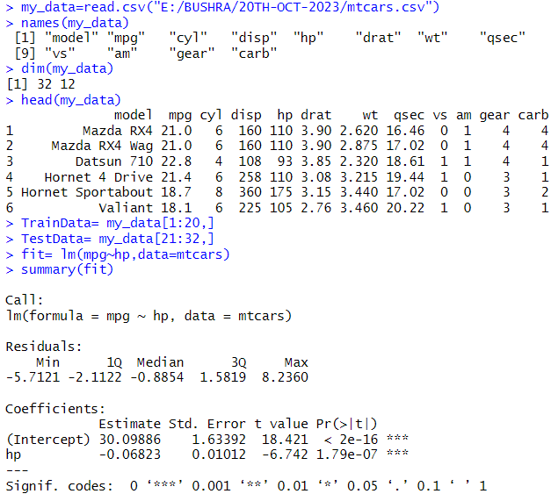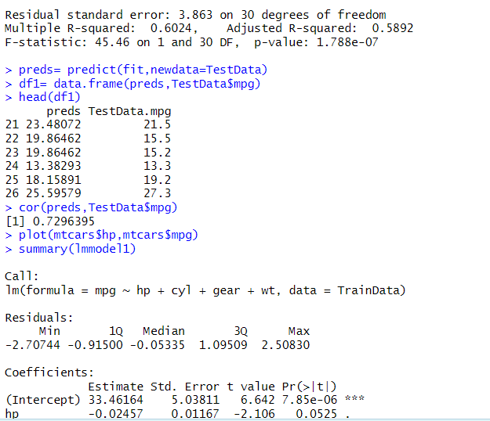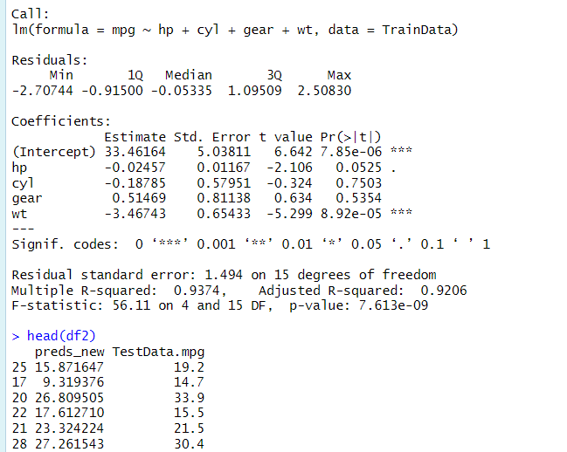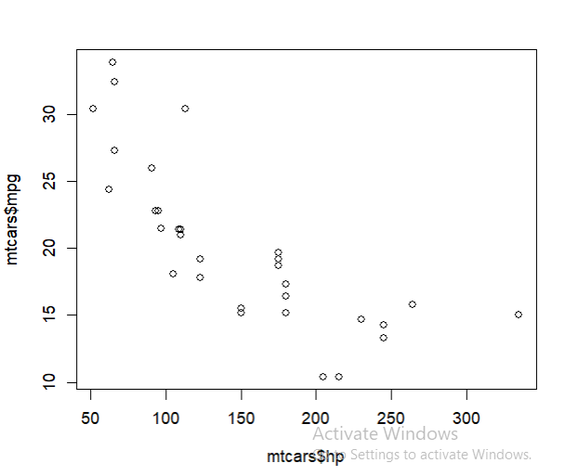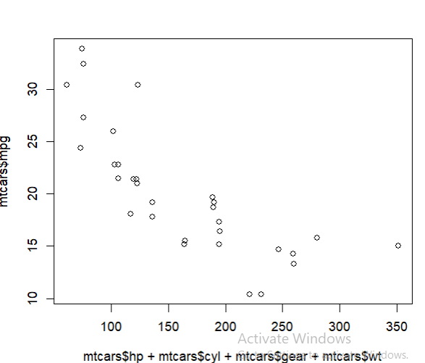

**Practical No:-15**

**Aim:-Clustering – Implementation of K-Means.**

**CODE:**

#K-Means and Agglomeartive Clustering

data=read.csv("B:/R-lab/iris1.csv")

head(iris)

install.packages("ggplot2")

library(ggplot2)

ggplot(iris, aes(Petal.Length,Petal.Width,color=Species))+geom_point()

set.seed(20)

irisCluster=kmeans(iris[.3:4],3,nstart = 20)

irisCluster

table(irisCluster$cluster,iris$Species)

irisCluster$cluster=as.factor(irisCluster$cluster)

ggplot(iris,aes(Petal.Length,Petal.Width,color=irisCluster$cluster))+geom_point()

**OUTPUT:**

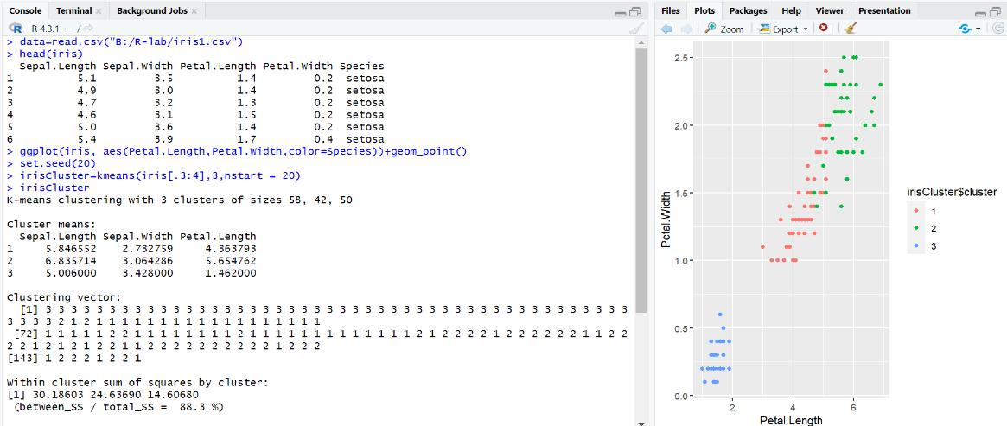 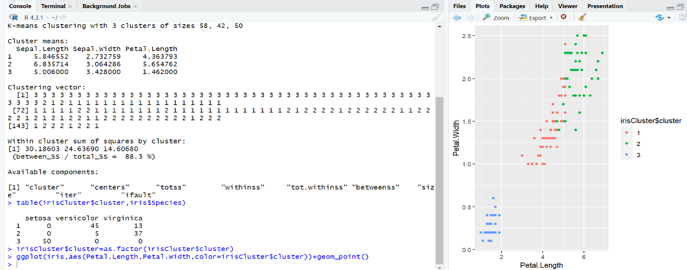

Practical exam Questions

|  |  |  |  |  |  |  |  |  |  |  |  |  |
| --- | --- | --- | --- | --- | --- | --- | --- | --- | --- | --- | --- | --- |
| Perform Apriori algorithm on following dataset and find strong association rule with support=50% and confidence=70%.   |  |  | | --- | --- | | Transaction Id | Items | | 100 | Ink Pen, Notebook, Drawing book, Marker | | 200 | Ink Pen, Notebook, Drawing book | | 300 | Ink Pen, Sharpener, Crayons | | 400 | Ink Pen, Drawing Book, Sharpner | | 500 | Note book, Drawing book, Sharpener | |

Code:

# Install and load the "arules" package

install.packages("arules")

library(arules)

# Create a data frame with the given dataset

transactions <- data.frame(

TransactionId = c(100, 200, 300, 400, 500),

Items = c(

"Ink Pen, Notebook, Drawing book, Marker",

"Ink Pen, Notebook, Drawing book",

"Ink Pen, Sharpener, Crayons",

"Ink Pen, Drawing Book, Sharpener",

"Notebook, Drawing book, Sharpener"

),

stringsAsFactors = FALSE

)

# Convert the items column to a transaction format

transactions <- strsplit(transactions$Items, ", ")

transactions <- lapply(transactions, as.character)

transactions <- as(transactions, "transactions")

# Apply Apriori algorithm

rules <- apriori(

transactions,

parameter = list(support = 0.5, confidence = 0.7),

control = list(verbose = FALSE)

)

# Display the rules

inspect(rules)

Q 2

|  |  |
| --- | --- |
| Sample Iris dataset. Divide them into 80% training and 20% test data. Perform the NaiveBayes classification on this data. Show crosstab validations. Explain the output. | 15 |

Code:

# Load required libraries

install.packages("caret")

install.packages("e1071")

library(caret)

library(e1071)

# Load the Iris dataset

data(iris)

# Set a seed for reproducibility

set.seed(123)

# Split the data into training (80%) and testing (20%) sets

splitIndex <- createDataPartition(iris$Species, p = 0.8, list = FALSE)

train_data <- iris[splitIndex, ]

test_data <- iris[-splitIndex, ]

# Train a Naive Bayes model

nb_model <- naiveBayes(Species ~ ., data = train_data)

# Make predictions on the test set

predictions <- predict(nb_model, newdata = test_data)

# Create a confusion matrix

conf_matrix <- table(Actual = test_data$Species, Predicted = predictions)

# Show the confusion matrix

print("Confusion Matrix:")

print(conf_matrix)

# Calculate accuracy

accuracy <- sum(diag(conf_matrix)) / sum(conf_matrix)

print(paste("Accuracy:", accuracy))

# Show crosstab validation

crossTable(test_data$Species, predictions, prop.chisq = FALSE)

Q 3 Perform the NaiveBayes classification on following dataset and predict the class for unseen sample {chills=yes, runny_nose=no, headache=mild, fever=yes}

|  |  |  |  |  |
| --- | --- | --- | --- | --- |
| Chills | Runny_nose | Headache | Fever | Flu |
| Yes | No | Mild | No | No |
| Yes | Yes | Mild | No | Yes |
| Yes | No | Strong | Yes | Yes |
| No | Yes | Mild | No | Yes |
| No | Yes | Mild | Yes | No |
| No | No | Strong | Yes | Yes |
| No | No | Strong | No | No |
| Yes | No | Strong | Yes | No |
| Yes | Yes | No | No | Yes |

Code:

# Install and load the required library

install.packages("e1071")

library(e1071)

# Create the dataset

data <- data.frame(

Chills = c("Yes", "Yes", "Yes", "No", "No", "No", "No", "Yes", "Yes"),

Runny_nose = c("No", "Yes", "No", "Yes", "Yes", "No", "No", "No", "Yes"),

Headache = c("Mild", "Mild", "Strong", "Mild", "Mild", "Strong", "Strong", "Strong", "No"),

Fever = c("No", "No", "Yes", "No", "Yes", "Yes", "No", "Yes", "No"),

Flu = c("No", "Yes", "Yes", "Yes", "No", "Yes", "No", "No", "Yes")

)

# Convert categorical variables to factors

data$Chills <- as.factor(data$Chills)

data$Runny_nose <- as.factor(data$Runny_nose)

data$Headache <- as.factor(data$Headache)

data$Fever <- as.factor(data$Fever)

data$Flu <- as.factor(data$Flu)

# Train a Naive Bayes model

nb_model <- naiveBayes(Flu ~ Chills + Runny_nose + Headache + Fever, data = data)

# Define the unseen sample

unseen_sample <- data.frame(

Chills = "Yes",

Runny_nose = "No",

Headache = "Mild",

Fever = "Yes"

)

# Predict the class for the unseen sample

prediction <- predict(nb_model, unseen_sample)

# Print the prediction

print("Predicted Class:")

print(prediction)

Q3 Create table Book(BooksID, Author, Booknname, price)

a)Add a sequence.

b) Export the output in output table.

c) Display the added sequence in oracle.

C:

-- a) Creating the Book table with a sequence

CREATE TABLE Book (

BooksID NUMBER PRIMARY KEY,

Author VARCHAR2(50),

BookName VARCHAR2(100),

Price NUMBER

);

-- Adding a sequence

CREATE SEQUENCE BookSeq

START WITH 1

INCREMENT BY 1

NOCACHE

NOCYCLE;

-- b) Inserting data into the Book table using the sequence

INSERT INTO Book (BooksID, Author, BookName, Price)

VALUES (BookSeq.NEXTVAL, 'Author1', 'BookName1', 19.99);

INSERT INTO Book (BooksID, Author, BookName, Price)

VALUES (BookSeq.NEXTVAL, 'Author2', 'BookName2', 29.99);

-- c) Exporting the output to another table

CREATE TABLE OutputTable AS

SELECT * FROM Book;

-- Displaying the added sequence in Oracle

SELECT BookSeq.CURRVAL AS CurrentValue FROM DUAL;

Q 4 Create a type Type_A and a type Type_B(Assume col names on your own) and the create a table customer. Assign both types to customer table. Insert the records and display the records.

-- Create Type_A

CREATE TYPE Type_A AS OBJECT (

col1 NUMBER,

col2 VARCHAR2(50)

);

-- Create Type_B

CREATE TYPE Type_B AS OBJECT (

col3 NUMBER,

col4 VARCHAR2(50)

);

-- Create Customer table with Type_A and Type_B

CREATE TABLE Customer (

id NUMBER,

info_A Type_A,

info_B Type_B

);

-- Insert records into the Customer table

INSERT INTO Customer VALUES (1, Type_A(1, 'John'), Type_B(25.5, 'Doe'));

INSERT INTO Customer VALUES (2, Type_A(2, 'Jane'), Type_B(30.0, 'Smith'));

-- Display records

SELECT * FROM Customer;

Q5 Perform Hierarchical clustering on Iris data set. Explain the output.

# Load the Iris dataset

data(iris)

# Extracting the features (excluding the species column)

iris_features <- iris[, 1:4]

# Perform hierarchical clustering

hc <- hclust(dist(iris_features), method = "complete")

# Plot the dendrogram

plot(hc, main = "Hierarchical Clustering Dendrogram", xlab = "Species", sub = NULL)

# Cut the dendrogram to create clusters

clusters <- cutree(hc, k = 3) # You can adjust the number of clusters as needed

# Add cluster information to the original dataset

iris_with_clusters <- cbind(iris, Cluster = clusters)

# Display the resulting dataset with cluster assignments

print(iris_with_clusters)

Q Create a table Item(ItemID, Item_name, Item_price, Item_qty)

1. Calculate the amount as (Item_price*Item_qty).
2. Export the output in new table.
3. Display the records in oracle.

-- a) Create the Item table

CREATE TABLE Item (

ItemID NUMBER PRIMARY KEY,

Item_name VARCHAR2(50),

Item_price NUMBER,

Item_qty NUMBER

);

-- Insert some sample data

INSERT INTO Item VALUES (1, 'Item1', 10.99, 5);

INSERT INTO Item VALUES (2, 'Item2', 15.49, 3);

INSERT INTO Item VALUES (3, 'Item3', 8.99, 7);

-- b) Calculate the amount and export to a new table

CREATE TABLE ItemAmount AS

SELECT ItemID, Item_name, Item_price, Item_qty, (Item_price * Item_qty) AS Amount

FROM Item;

-- c) Display records from the original and new tables

-- Original table

SELECT * FROM Item;

-- New table with calculated amount

SELECT * FROM ItemAmount;

Q6

|  |  |  |  |  |  |  |  |  |  |  |  |  |  |  |  |  |
| --- | --- | --- | --- | --- | --- | --- | --- | --- | --- | --- | --- | --- | --- | --- | --- | --- |
| |  |  |  |  |  |  |  |  |  |  |  |  |  |  |  |  | | --- | --- | --- | --- | --- | --- | --- | --- | --- | --- | --- | --- | --- | --- | --- | --- | | Perform k-means clustering for given data set. Take k=2   |  |  |  | | --- | --- | --- | | **Medicine** | **Attribute1 (x): weight index** | **Attribute2 (y): pH** | | **A** | 1 | 1 | | **B** | 2 | 1 | | **C** | 4 | 3 | | **D** | 5 | 4 | | |

# Create the data frame

data <- data.frame(

Medicine = c("A", "B", "C", "D"),

Attribute1 = c(1, 2, 4, 5),

Attribute2 = c(1, 1, 3, 4)

)

# Selecting relevant columns for clustering

cluster_data <- data[, c("Attribute1", "Attribute2")]

# Perform k-means clustering with k=2

k <- 2

kmeans_result <- kmeans(cluster_data, centers = k)

# Add cluster assignments to the original data

data$Cluster <- as.factor(kmeans_result$cluster)

# Display the results

print("Original Data:")

print(data)

print("\nK-Means Clustering Result:")

print(kmeans_result)

Q 8 Create table Customer(ID, Fname,Lname,Address)

1. Perform concatenation on Fname and Lname.
2. Store the output in new table and display records in oracle.
3. Sort the records on Fname.

-- a) Create the Customer table

CREATE TABLE Customer (

ID NUMBER PRIMARY KEY,

Fname VARCHAR2(50),

Lname VARCHAR2(50),

Address VARCHAR2(100)

);

-- Insert some sample data

INSERT INTO Customer VALUES (1, 'John', 'Doe', '123 Main St');

INSERT INTO Customer VALUES (2, 'Jane', 'Smith', '456 Oak St');

INSERT INTO Customer VALUES (3, 'Bob', 'Johnson', '789 Pine St');

-- b) Concatenate Fname and Lname, store the output in a new table

CREATE TABLE CustomerConcatenated AS

SELECT ID, Fname || ' ' || Lname AS Fullname, Address

FROM Customer;

-- c) Sort the records on Fname

SELECT * FROM CustomerConcatenated

ORDER BY Fname;

Q 9

|  |  |  |  |  |  |  |  |  |  |  |  |  |  |  |  |  |  |  |  |  |  |  |  |  |  |
| --- | --- | --- | --- | --- | --- | --- | --- | --- | --- | --- | --- | --- | --- | --- | --- | --- | --- | --- | --- | --- | --- | --- | --- | --- | --- |
| Create given data frame. Write commands to  1.show NA values for each column  2.show position of NA values  3.count missing values  4.show non-NA values using 2 different method  5. Give names to columns  6. Impute missing value in col4 using mean   |  |  |  |  |  | | --- | --- | --- | --- | --- | |  | col1 | col2 | col3 | col4 | | 1 | 1 | this | TRUE | 2.5 | | 2 | 2 | <NA> | FALSE | 4.2 | | 3 | 3 | is | TRUE | 3.2 | | 4 | NA | text | TRUE | NA | |

# Create the data frame

df <- data.frame(

col1 = c(1, 2, 3, NA),

col2 = c("this", NA, "is", "text"),

col3 = c(TRUE, FALSE, TRUE, TRUE),

col4 = c(2.5, 4.2, 3.2, NA)

)

# 1. Show NA values for each column

print("1. Show NA values for each column:")

print(colSums(is.na(df)))

# 2. Show position of NA values

print("\n2. Show position of NA values:")

print(which(is.na(df), arr.ind = TRUE))

# 3. Count missing values

print("\n3. Count missing values:")

print(sum(is.na(df)))

# 4. Show non-NA values using 2 different methods

print("\n4. Show non-NA values using 2 different methods:")

print("Method 1:")

print(df[complete.cases(df), ]) # Method 1: using complete.cases

print("\nMethod 2:")

print(df[!is.na(df$col1) & !is.na(df$col2) & !is.na(df$col3) & !is.na(df$col4), ]) # Method 2: using individual columns

# 5. Give names to columns

print("\n5. Give names to columns:")

colnames(df) <- c("ID", "Description", "Flag", "Value")

print(df)

# 6. Impute missing value in col4 using mean

print("\n6. Impute missing value in col4 using mean:")

df$col4[is.na(df$col4)] <- mean(df$col4, na.rm = TRUE)

print(df)

Q Create a table employee with attribute empid, name, deptid,deptname, salary and joining date.

Using Number range display the designation of employees based on salary(e.g if salary <=20000 then clerk etc).

-- Create the employee table

CREATE TABLE employee (

empid NUMBER PRIMARY KEY,

name VARCHAR2(50),

deptid NUMBER,

deptname VARCHAR2(50),

salary NUMBER,

joining_date DATE

);

-- Insert some sample data

INSERT INTO employee VALUES (1, 'John Doe', 101, 'IT', 25000, TO_DATE('2022-01-01', 'YYYY-MM-DD'));

INSERT INTO employee VALUES (2, 'Jane Smith', 102, 'HR', 18000, TO_DATE('2022-02-15', 'YYYY-MM-DD'));

INSERT INTO employee VALUES (3, 'Bob Johnson', 103, 'Finance', 30000, TO_DATE('2022-03-20', 'YYYY-MM-DD'));

-- Add more sample records as needed

-- Display the table

SELECT * FROM employee;

-- Use a CASE statement to display designation based on salary

SELECT

empid,

name,

salary,

CASE

WHEN salary <= 20000 THEN 'Clerk'

WHEN salary <= 30000 THEN 'Officer'

WHEN salary <= 40000 THEN 'Manager'

ELSE 'Director'

END AS designation

FROM employee;

Q 5 Import missing_col.csv file into R. Write commands to

1.Show non-NA values.

2. Give names to each column.

3. Store all non-NA values in a new_col.xlsx file.

4. Display contents of new_col.xlsx file.

# Install and load required packages

install.packages("readxl")

library(readxl)

library(openxlsx)

# 1. Import the missing_col.csv file into R

data <- read.csv("missing_col.csv")

# 2. Show non-NA values

print("1. Show non-NA values:")

print(na.omit(data))

# 3. Give names to each column

colnames(data) <- c("ID", "Name", "Salary", "Department")

# 4. Store all non-NA values in a new_col.xlsx file

write.xlsx(na.omit(data), "new_col.xlsx")

# 5. Display contents of new_col.xlsx file

print("Contents of new_col.xlsx:")

read.xlsx("new_col.xlsx")

Q Perform linear regression on women data set available with R. Predict the weight of women if height is 67 inches. Plot the graph of height Vs. Weight. Draw best fit line.

# Load the women dataset

data(women)

# Perform linear regression

model <- lm(weight ~ height, data = women)

# Predict the weight for height = 67 inches

predicted_weight <- predict(model, newdata = data.frame(height = 67))

# Print the predicted weight

print("Predicted Weight for Height = 67 inches:")

print(predicted_weight)

# Plot the graph of height vs. weight with the best-fit line

plot(women$height, women$weight, main = "Height vs. Weight with Linear Regression Line",

xlab = "Height (inches)", ylab = "Weight (lbs)")

abline(model, col = "red") # Draw the best-fit line in red

Q Perform linear regression on BOD data set available with R. Predict the oxygen demand if day is 6. Plot the graph. Draw best fit line.

# Load the BOD dataset

data(BOD)

# Perform linear regression

model <- lm(demand ~ Time, data = BOD)

# Predict the oxygen demand for day = 6

predicted_demand <- predict(model, newdata = data.frame(Time = 6))

# Print the predicted oxygen demand

print("Predicted Oxygen Demand for Day = 6:")

print(predicted_demand)

# Plot the graph of Time vs. Demand with the best-fit line

plot(BOD$Time, BOD$demand, main = "Time vs. Demand with Linear Regression Line",

xlab = "Day", ylab = "Oxygen Demand")

abline(model, col = "red") # Draw the best-fit line in red

Q a) Use CSV file as an input and store the output in table.

b) Perform sort operation on any particular column.

c) Store the output in a table and display the records in oracle.

Assuming you have a CSV file named your_data.csv, and you want to load it into an Oracle table, sort it by a particular column, store the output in another table, and then display the records, you could follow these steps:

sql

Copy code

-- Step 1: Create a table to store the CSV data

CREATE TABLE YourTable (

-- Define your columns based on your CSV file structure

Column1 NUMBER,

Column2 VARCHAR2(50),

Column3 DATE,

-- Add more columns as needed

);

-- Step 2: Use SQL*Loader or other methods to load data from CSV into the table

-- Assuming CSV file has a header, and the data is comma-separated.

-- Run the following command in the command line (outside of SQL*Plus):

-- sqlldr username/password@dbname control=your_control_file.ctl

-- Example control file (your_control_file.ctl):

-- LOAD DATA

-- INFILE 'your_data.csv'

-- APPEND

-- INTO TABLE YourTable

-- FIELDS TERMINATED BY ',' optionally enclosed by '"'

-- (Column1, Column2, Column3)

-- Step 3: Perform sort operation

-- Let's assume you want to sort by Column1

CREATE TABLE SortedTable AS

SELECT *

FROM YourTable

ORDER BY Column1;

-- Step 4: Display the records

-- Replace 'LIMIT' with the number of records you want to display

SELECT * FROM SortedTable WHERE ROWNUM <= 10;

Q Find all missing values in air quality data set available with R.

Impute missing values for solar.R and Ozone with the median.

Perform multiple linear regression on this imputed data. Plot the graph Solar.R Vs. Ozone. Draw best fit line.

# Load the air quality dataset

data(airquality)

# Display the structure of the dataset

str(airquality)

# 1. Find missing values

print("1. Missing values in the air quality dataset:")

print(sum(is.na(airquality)))

# 2. Impute missing values for Solar.R and Ozone with median

airquality$Solar.R[is.na(airquality$Solar.R)] <- median(airquality$Solar.R, na.rm = TRUE)

airquality$Ozone[is.na(airquality$Ozone)] <- median(airquality$Ozone, na.rm = TRUE)

# 3. Perform multiple linear regression

model <- lm(Ozone ~ Solar.R + Wind + Temp, data = airquality)

# 4. Plot the graph Solar.R Vs. Ozone with best fit line

plot(airquality$Solar.R, airquality$Ozone, main = "Solar.R Vs. Ozone with Linear Regression Line",

xlab = "Solar.R", ylab = "Ozone")

abline(model, col = "red") # Draw the best-fit line in red

Q Create two vectors as experience=( 3,8,9,13,3,6,11,21,1,16), salary=( 1,2,3,4,5,6,7,8,9,10). Perform linear regression on these vector and predict if experience of an employee is 20 years then what will be salary amount? Plot the graph. Draw best fit line.

# Create vectors

experience <- c(3, 8, 9, 13, 3, 6, 11, 21, 1, 16)

salary <- c(1, 2, 3, 4, 5, 6, 7, 8, 9, 10)

# Perform linear regression

model <- lm(salary ~ experience)

# Predict salary for experience = 20

predicted_salary <- predict(model, newdata = data.frame(experience = 20))

# Print the predicted salary

print("Predicted Salary for Experience = 20 years:")

print(predicted_salary)

# Plot the graph of experience vs. salary with best fit line

plot(experience, salary, main = "Experience vs. Salary with Linear Regression Line",

xlab = "Experience (years)", ylab = "Salary")

abline(model, col = "red") # Draw the best-fit line in red

Q

|  |  |
| --- | --- |
| Q.1 | Create a table patient(ID, name, age,vaccine_taken)  a) Perform validation on vaccine_taken(yes/No)  b) patients whose vaccine_taken is Yes should be validated.  c) Perform range operation on age. Those whose age is between 30 to 45 is eligible. |

-- Step 1: Create the patient table

CREATE TABLE patient (

ID INT PRIMARY KEY,

name VARCHAR2(50),

age INT,

vaccine_taken VARCHAR2(3) CHECK (vaccine_taken IN ('Yes', 'No'))

);

-- Step 2: Insert sample data into the patient table

INSERT INTO patient VALUES (1, 'John Doe', 40, 'Yes');

INSERT INTO patient VALUES (2, 'Jane Smith', 25, 'No');

INSERT INTO patient VALUES (3, 'Bob Johnson', 35, 'Yes');

-- Add more patient records as needed

-- Step 3: Validation on vaccine_taken

-- Only 'Yes' or 'No' is allowed for vaccine_taken

-- No other values are allowed due to the CHECK constraint

-- Step 4: Patients whose vaccine_taken is 'Yes' should be validated

-- For example, you can perform further validations or actions for patients with vaccine_taken = 'Yes'

-- Step 5: Perform range operation on age (eligible age between 30 and 45)

SELECT *

FROM patient

WHERE vaccine_taken = 'Yes' AND age BETWEEN 30 AND 45;

Q Remove missing values in Orange dataset available with R. Scale data set. Perform hierarchical clustering on it. Show upper cut of the dendrogram.

# Load the Orange dataset

data(Orange)

# Remove missing values

Orange_no_missing <- na.omit(Orange)

# Scale the dataset

scaled_data <- scale(Orange_no_missing[, -c(1, 2)])

# Perform hierarchical clustering

hc_result <- hclust(dist(scaled_data), method = "complete")

# Plot the dendrogram with upper cut

plot(hc_result, main = "Hierarchical Clustering Dendrogram", xlab = "Observations", sub = NULL)

abline(h = 5, col = "red", lty = 2) # Set the upper cut at height 5 (adjust as needed)

qRemove missing values in Orange dataset available with R. Scale data set. Perform hierarchical clustering on it. Show upper cut of the dendrogram.

# Load the Orange dataset

data(Orange)

# Remove missing values

Orange_no_missing <- na.omit(Orange)

# Scale the dataset

scaled_data <- scale(Orange_no_missing[, -c(1, 2)])

# Perform hierarchical clustering

hc_result <- hclust(dist(scaled_data), method = "complete")

# Plot the dendrogram with upper cut

plot(hc_result, main = "Hierarchical Clustering Dendrogram", xlab = "Observations", sub = NULL)

abline(h = 5, col = "red", lty = 2) # Set the upper cut at height 5 (adjust as needed)